Estimates of harvest rates for naturally-produced coho in Oregon tributaries to the Lower Columbia River affected by Select Area fisheries, 2002-2006.
(Youngs Bay and Big Creek populations)

January 2008

Oregon Department of Fish and Wildlife
Ocean Salmon and Columbia River Program
Columbia River Fisheries Section

17330 SE Evelyn Street
Clackamas, Oregon 97015

Table of Contents
INTRODUCTION 5
BACKGROUND 5
Abundance 6
Run Timing 7
Productivity 12
Management of Hatchery Fish 13
Harvest of Marked Versus Unmarked Fish 14
Catch and Stock Composition 15
Harvest Rate Analysis 19
Escapement Estimates 19
Harvest Estimates 20
Harvest Rate Estimates 21
Feasibility of Escapement Estimates 27
References 31
Appendix A: Ancillary Data 32
Appendix B: Known Data Gaps and Adjustments Made 48

Tables and Figures
Table 1. Harvest of coho salmon in lower Columbia mainstem and Select Area commercial fisheries, 1993-2006¹. 6
Table 2. Estimated abundance (95% CIs in parentheses) of adult coho, total and unmarked only, for Youngs Bay and Big Creek, 2002-2006. 6
Figure 1. Time series of estimated 2002-2006 and back-calculated 1949-2001 coho AUC abundance estimates. 7
Figure 2. Run timing of wild coho adults at Gnat Creek weir, 1955-1962. 8
Figure 3. Average percent of coho catch by week in Youngs Bay fisheries, 1962-1966. Blue line indicates opening of fishery. 8
Figure 4. Percent of coho catch by week in Youngs Bay, 1975. Blue line indicates opening of fishery. 10
Figure 5. Percent of coho catch by week in Youngs Bay, 1978. Blue line indicates opening of fishery. 10
Figure 6. Percent of coho catch by week in Youngs Bay, 1979. Blue line indicates opening of fishery. 11
Figure 7. Average weekly catch of marked and unmarked coho in Oregon Select Area commercial fisheries, 2002-2006. 12
Table 3. Estimated production from Gnat Creek wild coho, 1955-1959 brood years. 13
Figure 8. Approximate spawner-to-spawner ratios for Youngs River and Big Creek (Little Cr surveys) coho populations, 1949-2006. Values are calculated from back-calculated estimates of spawner abundance for 1949-2001, and from AUC abundance estimates for 2002-2006. 13
Figure 5. Average weekly catch composition (percent marked and unmarked) of coho harvested in Select Area commercial fisheries, 2002-2006. Note y-scale range from 60% - 100% (necessary to show unmarked component). 15
Table 4. Estimated stock composition and origin of marked coho harvested in Oregon Select Area commercial fisheries, 2002-2006. 17
Table 5. Estimated stock composition and origin of unmarked coho (including jacks) harvested in Oregon Select Area commercial fisheries, 2002-2006. 18
Table 6. Results of scale analysis of unmarked adult coho from weir sites, 2002-2006. Includes all readings. 20
Table 7. Percentage of jacks in total coho catch in Select Areas, 2002-2006. 21
Table 8. Estimated Youngs Bay unmarked coho harvest rates (catch is from Youngs Bay). Includes adjustments based upon scale pattern analysis. 21
Table 9. Estimated Big Creek unmarked coho harvest rates (catch is from Tongue Point and Blind Slough). Includes adjustments based upon scale pattern analysis. 22
Table 10. Estimated Youngs Bay unmarked coho harvest rates (catch is from Youngs Bay). DOES NOT include adjustments based upon scale pattern analysis. 22
Table 11. Estimated Big Creek unmarked coho harvest rates (catch is from Tongue Point and Blind Slough). DOES NOT include adjustments based upon scale pattern analysis. 22
Table 12. Effects of errors in unmarked harvest estimates on harvest rate calculations (with scale pattern adjustment). 25
Figure 10. Effects of errors in unmarked harvest estimates and escapement estimates on harvest rate calculations. 26
Table 13. Effects of errors in unmarked escapement estimates on harvest rate calculations. 27
Table 14. Estimated spawner-to-spawner ratios for Youngs Bay and Big Creek coho populations, 2002-2003 brood years. Values include adjustments for scale pattern analysis. Values in parentheses are the corresponding values if the scale pattern adjustment is NOT used. 27
Table 15. Relative frequency of spawner-to-spawner ratios for the Sandy and Clackamas rivers, 1957-2003. 28
Appendix Table A1. Peak index counts of coho in Youngs River and Little Creek (tributary to Big Creek), 1949-2006. Counts are peak estimates in index sites after December 1 of each year. 32
Appendix Figure A1. Linear regression of peak index count versus AUC estimate for 2002-2006 Youngs Bay and Big Creek coho returns. 33
Appendix Table A2. Estimated total spawner abundance for Youngs Bay and Big Creek back-calculated from 2002-2006 peak count and AUC abundance estimates. Red text indicates interpolated or back-calculated data. 34
Appendix Table A3. Summary of coho releases in Youngs Bay and tributaries, 1962-1993. 36
Appendix Table A4. Summary of open fishing dates and peak catch dates for Youngs Bay Select Area fisheries, 1962-2005. 37
Appendix Table A5. Summary of releases of hatchery adult and jack coho in lower Columbia River tributaries, 1964-1984. 39
Appendix Table A6. Approximate spawner-to-spawner ratios for Youngs River and Big Creek (Little Creek surveys) coho, BYs 1949-2003. Estimates were derived using the back-calculated 1949-2001 and estimated 2002-2003 abundance. 41
Appendix Table A7. Estimated number of unmarked upper Columbia River coho caught in Select Area fisheries, 2002-2006. Estimates derived from CWT expansions as described above. 43
Appendix Table A8. Weekly marked and unmarked coho catch in Youngs Bay, 2000-2006. 43
Appendix Table A9. Weekly marked and unmarked coho catch in Tongue Point, 2000-2006. 43
Appendix Table A10. Weekly marked and unmarked coho catch in Blind Slough, 2000-2006. 44
Appendix Table A11. Weekly sample rates used to estimate catch of unmarked coho in Select Areas, 2002-2006. 45
Appendix Table A12. Weekly sampling rates for detection of CWT’s in Select Areas, 2002-2006. All sampled coho are electronically sampled for CWT detection. 46
Appendix Table A13. Weir counts in Youngs Bay tributaries, 2002-2006. 46
Appendix Table A14. Big Creek weir counts, 2002-2006. 46
Appendix Table A15. Results of scale analysis of adult coho from weir sites, 2002-2006. With confidence classifications1 of 1 or 2 where possible. 47

INTRODUCTION
As part of the “Supplemental Biological Assessment of Incidental Impacts to Lower Columbia River Coho and Lower Columbia River Chinook Listed Under the Endangered Species Act in 2007 Mainstem Columbia River Fisheries below The Dalles Dam”, we evaluated the harvest rate on “local” populations of coho caught in Select Area fisheries. We defined “local” for purposes of the analysis as originating in and returning to tributaries in Oregon that enter the Columbia River where Select Area fisheries occur. These include the Big Creek basin and Youngs Bay tributaries. The Youngs Bay populations would be expected to be impacted primarily by Select Area fisheries in Youngs Bay. The Big Creek population would be expected to be impacted by Tongue Point/South Channel (hereafter Tongue Point) and Blind Slough/Knappa Slough (hereafter Blind Slough) Select Area fisheries. Historically, naturally-produced coho in these systems were believed to be entirely early stock in terms of ocean distribution, but have been considered to have a “late” return time to tributaries. Available information for these areas is limited to estimates of adult returns. Although estimates of smolt capacity based on available habitat have been made for these systems, no information is available at this time to quantify juvenile coho production.

In the biological assessment, we noted that we would continue to refine our analyses as we assembled additional information. This document describes the next iteration of our analyses and, in essence, supersedes the analyses contained in the biological assessment.

BACKGROUND
Select Area fisheries for coho salmon in Youngs Bay, Tongue Point/South Channel, Blind/Knappa sloughs, and Deep River are highly valuable for the Oregon and Washington commercial fleets. Since 1993, Select Area fisheries have accounted for 43% of the total non-Indian commercial coho harvest in the Columbia River (Table 1). Although catches and effort have historically been low, recreational fisheries in Select Areas are open year round for hatchery-produced salmon. Coho produced by the Select Area Fisheries Enhancement (SAFE) program are harvested in ocean commercial and recreational, mainstem commercial and recreational, Buoy 10 recreational, and Select Area commercial and recreational fisheries. Both states have invested extensive effort and capital in establishing, maintaining, and improving Select Area commercial and recreational fisheries.

The intent of Select Area fisheries is to allow harvest of hatchery-produced fish with minimal impacts to listed stocks from the mainstem Columbia. However, with the listing of lower Columbia River coho, Select Area fisheries now have a direct impact on a listed stock.

Table 1. Harvest of coho salmon in lower Columbia mainstem and Select Area commercial fisheries, 1993-2006¹.
Year | Mainstem Harvest | SAFE Harvest
1993 | 20,700 | 15,500
1994 | 6,000 | 57,800
1995 | 200 | 22,300
1996 | 5,600 | 22,300
1997 | 2,800 | 16,900
1998 | 300 | 24,100
1999 | 57,600 | 23,000
2000 | 112,400 | 61,700
2001 | 219,700 | 33,800
2002 | 94,900 | 69,300
2003 | 149,800 | 114,400
2004 | 66,500 | 51,900
2005 | 32,400 | 65,800
2006 | 28,400 | 37,700
¹ 1993-2005 is from North et al. 2006; 2006 from ODFW preliminary data

Abundance
Declines in abundance of naturally-produced fish in lower Columbia River tributaries, including the Big Creek basin and Youngs Bay tributaries, since the 1970s are well documented. Since 2000, abundances as measured by index counts (Appendix Table A1), have generally increased in these tributaries.

Since 2002, ODFW has estimated total spawner abundance of adult coho in these locations using the EMAP protocol (Suring et al. 2006). Although estimates of coho abundance in these areas have been relatively high in some years, on average, unmarked fish have comprised only 12% of the estimated abundance (Table 2). Examination of scales collected by other studies in these areas indicates that many of the unmarked fish present are of hatchery origin.

Table 2. Estimated abundance (95% CIs in parentheses) of adult coho, total and unmarked only, for Youngs Bay and Big Creek, 2002-2006.
 | Youngs Bay |  | Big Creek
 | Total | Unmarked | Total | Unmarked
2002¹ | 2,870 (2,761) | 364 (350) | 918 (836) | 52 (48)
2003¹ | 759 (549) | 45 (32) | 413 (246) | 122 (73)
2004¹ | 1,014 (718) | 128 (91) | 265 (340) | 0 (0)
2005¹ | 319 (253) | 77 (61) | 163 (129) | 39 (31)
2006² | 241 (376) | 28 (44) | 345 (500) | 40 (58)
¹ Source: Suring et al. 2006 – REVISED December 2007; Personal Comm. (ODFW Truemper).
² Source: from http://oregonstate.edu/dept/ODFW/spawn/cohoabund.htm. Sample size and survey methodology not consistent in 2006 with AUC protocols.

Using the AUC abundance estimates and index counts for 2002-2006, we back-calculated estimated abundance for the years 1949-2001 based on the historic index counts (Appendix Table A2 and Appendix Figure 1). As shown in Appendix Figure 1, the relationship between the AUC estimates and index counts for 2002-2006 were quite strong and the regression had a good fit (r²=0.97 Big Creek and r²=0.81 Youngs Bay) however the sample sizes are very small. Although this relationship may not suitable for making robust estimates of past total abundances, the estimates provide some additional perspective on long-term abundance trends (Figure 1).

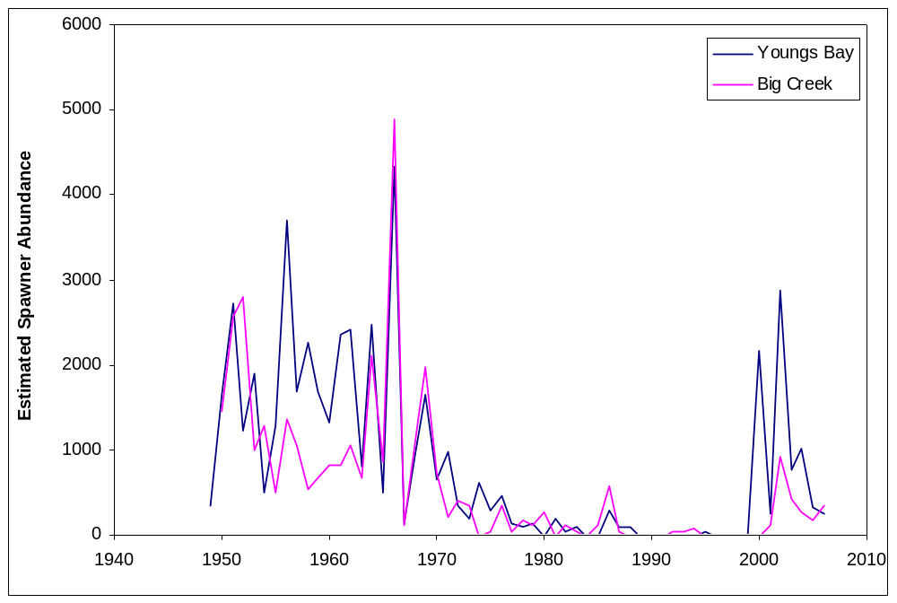

Figure 1. Time series of estimated 2002-2006 and back-calculated 1949-2001 coho AUC abundance estimates.

Run Timing
Return timing of wild fish in these areas was historically variable and extended over a long period of time, likely from August through January, with some spawning taking place as late as March. Over time, it appears that the earlier component of this return in the lower Columbia tributaries either disappeared, or became a part of the early hatchery returns through domestication or interbreeding. The late wild component has been documented in spawning ground surveys since 1949, and was usually seen on the spawning grounds in late-November and December. Validation of the natural origin of these wild fish through scale reading and other methods occurred in several years over the period these surveys were conducted. Since the 1970s and 1980s, late-season wild spawning has been extremely depressed. Recent surveys (Suring et al. 2006) have documented the presence of unmarked coho on the spawning grounds early in the spawning season, concurrent with the presence of hatchery fish, however the sample sizes used to determine origin may have been too small to determine whether the unmarked fish seen were of wild-origin, or were unmarked hatchery fish. Relatively few unmarked coho were observed in these areas during the “late” portion of the spawning season (after December 1). Two sources of information that may be useful for describing historic run timing of wild fish from these areas are collections at the Gnat Creek weir from 1955-1962 (Figure 2), and catches in the earliest Youngs Bay coho fisheries from 1962-1966 (Figure 3).

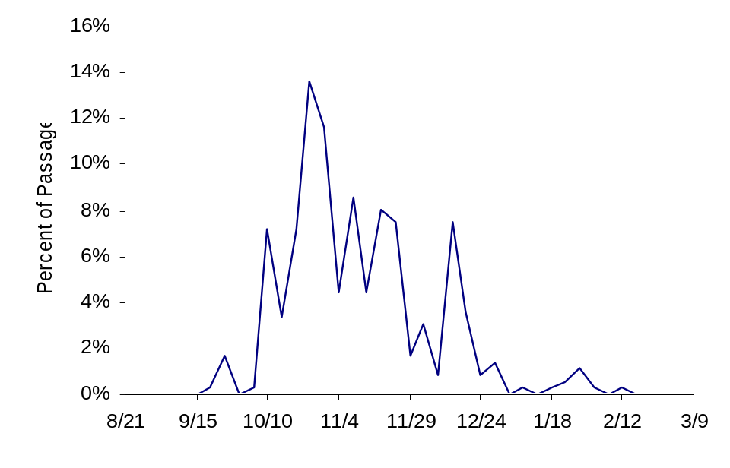

Figure 2. Run timing of wild coho adults at Gnat Creek weir, 1955-1962.

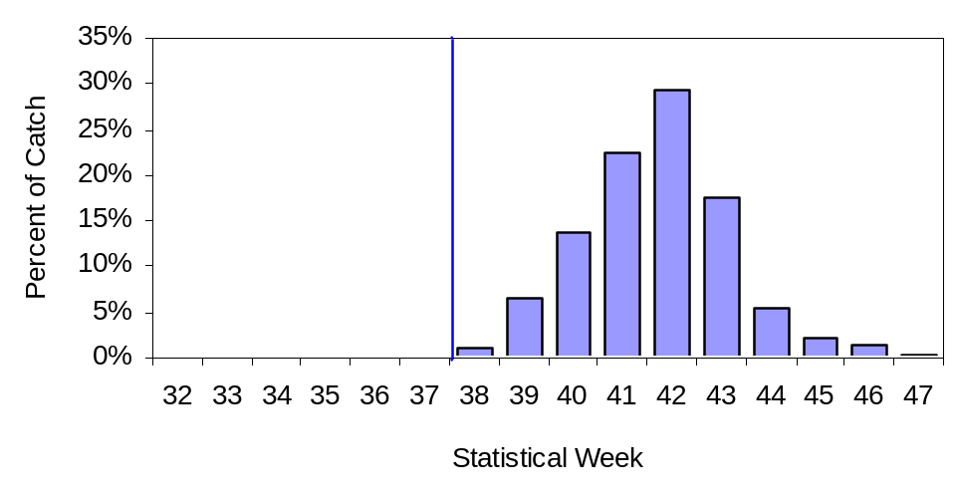

Figure 3. Average percent of coho catch by week in Youngs Bay fisheries, 1962-1966. Blue line indicates opening of fishery.

It should be noted that run timing has likely been significantly affected by hatchery programs that have been in place since the early 1900s. The Klaskanine Hatchery facility began operation in 1911. Early operations were heavily dependent on egg transfers into the program from coastal streams and other lower Columbia tributaries. By 1924, the hatchery was largely collecting eggs from fish collected in the North Fork Klaskanine. It is likely that these fish had already been impacted to some degree by hatchery practices prior to 1924, including the out of basin imports of eggs. Additionally, although Klaskanine collected most of their eggs on site, they did import fish and eggs from other facilities at various times after 1924, usually from other lower Columbia tributaries. The combination of these factors may mean that the timing of fish returning to Klaskanine Hatchery did not necessarily reflect the timing of the original wild stock. However, the timing to Klaskanine Hatchery appears to have been slightly later than some other “early” stock hatchery returns.

If the timing of fish sampled at Gnat Creek weir represents the historic timing of wild fish in all lower Columbia tributaries, then peak migration would have occurred in the last week of October, although substantial numbers of fish also returned after the peak (Figure 2). Gnat Creek is a small tributary, and migration of coho into the creek is highly dependent upon rain-dependent flows. Coho historically inhabiting other streams in the lower Columbia near Astoria may also have been dependent upon increases in rainfall and stream flow to allow access to spawning areas.

Catches in the first Youngs Bay coho fisheries in the 1960s seem to reflect the timing of the Klaskanine Hatchery stock. During the 1960s, peak catches in the fisheries typically occurred in about week 41 of each year (Figure 3). The dates for week 41 vary from year to year, but usually occur in the first week or two of October. During the 1960s, coho in Youngs Bay were either produced at Klaskanine Hatchery or were naturally-produced. Hatchery marking programs at this time were not designed to distinguish hatchery fish from wild fish, so little data is available regarding the composition of hatchery and wild fish in the catch. However, reports from these early fisheries indicate that when available methods, such as scale analysis, were used to identify origin of the catch, the majority (>90%) were hatchery-reared fish.

The predominance of hatchery fish in Youngs Bay fisheries is consistent with the management intent to schedule the fisheries during the peak of expected returns of hatchery fish. During the late 1960s and early 1970s, these fisheries were liberalized and expanded to maximize harvest of hatchery surplus coho resulting from improved rearing and release strategies. The results were longer open periods for fishing, and larger physical boundaries for fishers to operate in. However, as late as 1975 and 1978, the peak catch timing for coho in Youngs Bay was still relatively similar to the 1960s (Figures 4 and 5).

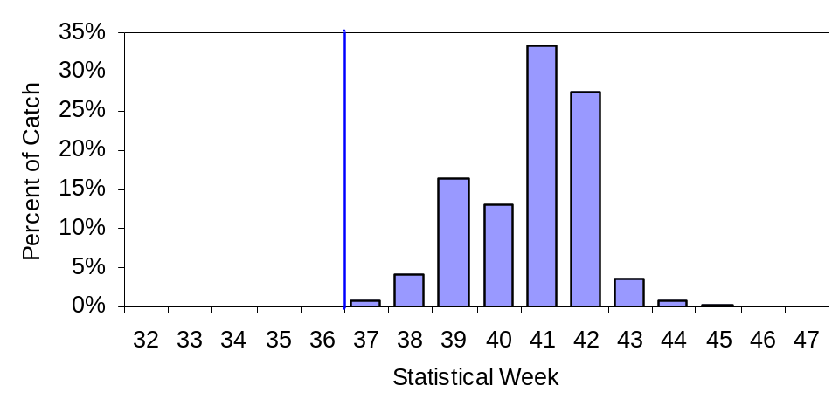

Figure 4. Percent of coho catch by week in Youngs Bay, 1975. Blue line indicates opening of fishery.

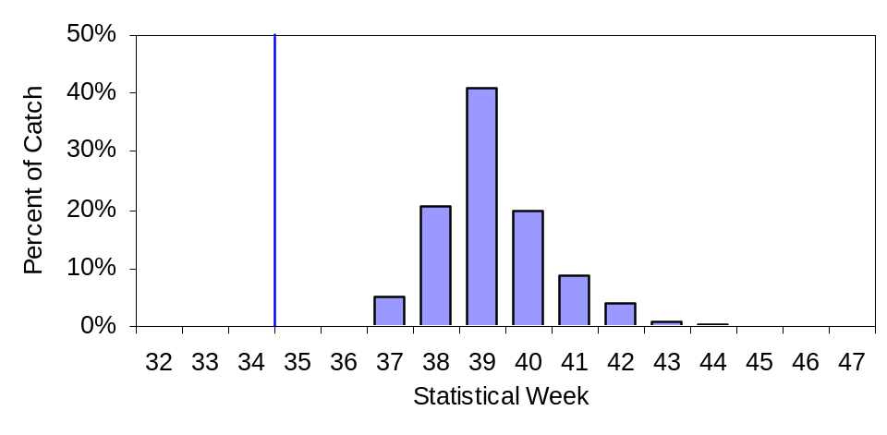

Figure 5. Percent of coho catch by week in Youngs Bay, 1978. Blue line indicates opening of fishery.

Beginning in 1979, however, Youngs Bay peak coho catches began occurring substantially earlier in the year (Figure 6). The Clatsop Economic Development Council (CEDC) program began releasing coho from the S.F. Klaskanine Facility in 1977. Most of the coho released by this program came from early-returning coho from Bonneville and Clackamas facilities. ODFW was still releasing substantial numbers of coho from Klaskanine Hatchery during this time period, and the ODFW releases made up the majority of coho released in Youngs Bay until the 1990s (Appendix Table A3). It seems unlikely that the relatively small (at the time) addition of CEDC releases of earlier-returning fish would have caused, or even significantly contributed to, the magnitude of change in timing of catch seen between 1978 and 1979. It is possible that the shift in peak catch was more related to earlier openings of the fishery and the effects of changing effort patterns among fishers. Prior to 1977, Youngs Bay typically opened in early to mid-September. In 1977, the fishery opened on August 25, and since that time has opened as early as August 8. In 1978 the fishery opened on August 24, and peak catch occurred five weeks later, during week 39 (Figure 5). In 1979, the fishery opened on August 22, and peak catch occurred only three weeks later, during week 36 (Figure 6). It seems likely that through 1977, return timing was either similar to that seen in the 1960s, or was only slightly earlier. It should be noted that in nearly all years of the Youngs Bay fishery, peak catches were 3-5 weeks after the opening of the season. This would indicate that the fishing schedules were effective in starting seasons prior to the peak of the run, and is counter to the idea that fish were historically available in Youngs Bay early in the run, but not caught due to the later opening dates used in fisheries prior to 1977. Changes in timing and magnitude of fishing effort and interactions with management of mainstem Columbia River fisheries could also explain the shifts in peak catch timing, but these have not been examined yet.

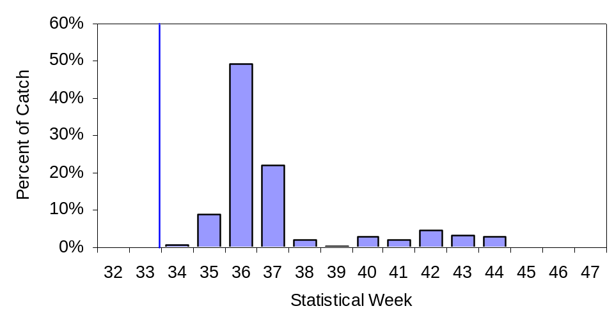

Figure 6. Percent of coho catch by week in Youngs Bay, 1979. Blue line indicates opening of fishery.

By the 1990s, definite shifts in return timing were evident (Figure 7). As part of efforts to reduce impacts of fisheries on later-timed naturally-produced fish in these areas, and in order to shift the return of hatchery fish even earlier in the season to access hatchery coho and early returning fall Chinook produced at S.F. Klaskanine Hatchery (CEDC) and Big Creek Hatchery, the new Select Area Fishery Evaluation project (SAFE) began to utilize more early-returning stocks in these areas.
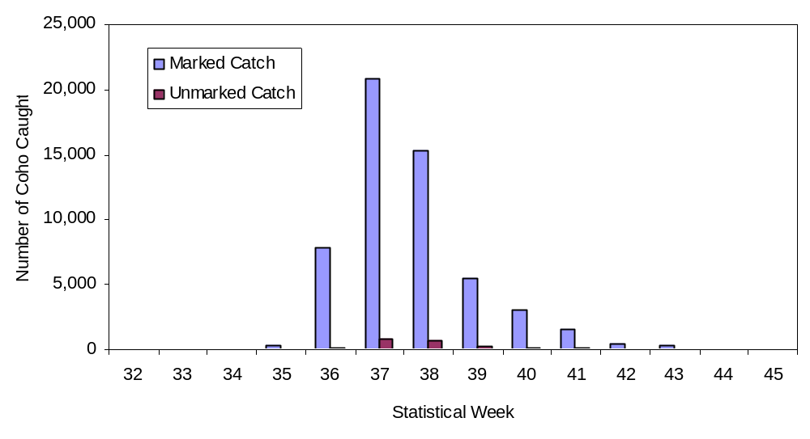

Figure 7. Average weekly catch of marked and unmarked coho in Oregon Select Area commercial fisheries, 2002-2006.

The historic and current timing of naturally-produced coho encountered in the Youngs Bay fishery remains unknown. To our knowledge, no tagging studies or other research have been conducted since the 1960s, to identify naturally-produced fish in the catch via scale analysis, nor to track the timing of their migration through the fishery. In 2007, ODFW began collecting scales from unmarked fish caught in Youngs Bay in an effort to partially address this issue. If naturally-produced fish returned at a later date than hatchery-produced fish, fishery operations would have a lower impact on naturally-produced fish. Large numbers of adult hatchery coho were released in upper areas of many of these tributaries from 1964-1984 (Appendix Table A5). Many of these fish were from Klaskanine Hatchery returns, and the remainder were from Big Creek Hatchery returns (early-returning stock). If those releases led to successful production, interactions between second-generation hatchery and naturally-reared fish may have contributed to the declines or shifts in timing for naturally-produced coho from these areas.

Productivity
In addition to returning adults, juvenile downstream migrants were also counted at the Gnat Creek weir during 1955-1962. If one assumes the adults counted at the weir produced all the juveniles captured as downstream migrants, estimated production would have ranged from 8 - 55 juveniles per adult (Table 3).

We used the back-calculated abundance data for the years 1949-2001 to calculate approximate spawner-to-spawner ratios for the Youngs River and Big Creek populations (Figure 8 and Appendix Table A6). Prior to the 1960s, hatchery returns to these areas were relatively small compared to current conditions. Therefore, spawner-to-spawner ratios for the time period 1949-1965 may represent realistic productivity approximations. Using the back-calculated AUC data, the average return-per-spawner for brood years 1949-1965 was 1.5 for both Youngs River and Big Creek. The maximum ratios seen during that period were 5.3 for Youngs River and 7.2 for Big Creek (both in 1963). If this range of productivity is representative of reasonable values for natural spawners in these areas, the numbers of unmarked fish currently observed are likely not all naturally-produced.

Table 3. Estimated production from Gnat Creek wild coho, 1955-1959 brood years.
Brood Year | Adults | Juveniles | Production
1955 | 93 | 2,996 | 32.2
1956 | 75 | 1,847 | 24.6
1957 | 120 | 1,013 | 8.4
1958 | 70 | 1,061 | 15.2
1959 | 59 | 3,226 | 54.7

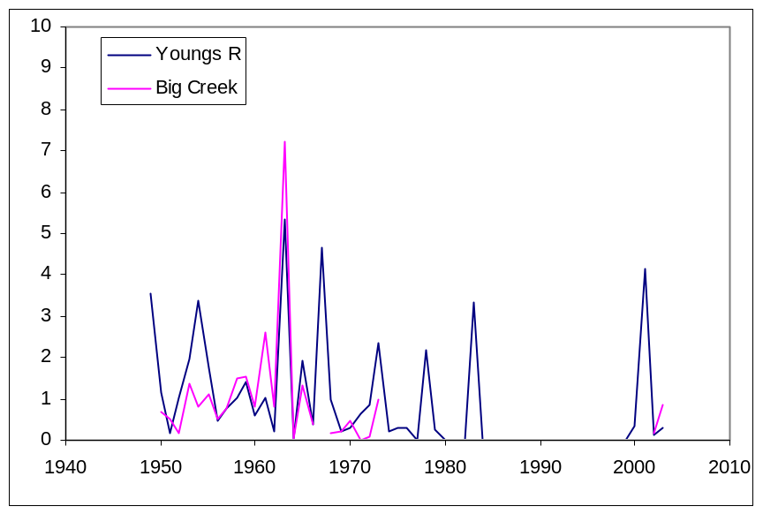

Figure 8. Approximate spawner-to-spawner ratios for Youngs River and Big Creek (Little Cr surveys) coho populations, 1949-2006. Values are calculated from back-calculated estimates of spawner abundance for 1949-2001, and from AUC abundance estimates for 2002-2006.

Management of Hatchery Fish
Select Area commercial fisheries are not mark-selective and are designed to target large returns of hatchery salmon at very high harvest rates. In fact, one goal of these fisheries is to harvest as many returning hatchery coho and spring Chinook from the system as possible. Currently, tributaries with weirs or fish traps (Big Creek and North Fork Klaskanine River) are restricted to passage of unmarked coho only, in an attempt to keep hatchery fish from intermingling with naturally-produced fish. However, some spawning of hatchery fish is known to occur in un-blocked tributaries (Lewis and Clark River, South Fork Klaskanine River, Youngs River, Gnat Creek, Mill Creek, Little Creek), and below barriers in blocked tributaries. Varying proportions of unmarked fish released above barriers are later found to be of hatchery origin.

Nearly 100% of hatchery coho currently released into the Big Creek basin and Youngs Bay are marked with adipose fin-clips, however, the large volume of releases means that missed or regenerated clips on even a small percentage of fish released from a hatchery can result in large numbers of unmarked fish returning. Thompson and Blankenship (1997) reported that 58%-87% of coho marked with incomplete adipose clips demonstrated partial or complete regeneration of the adipose fin. If relatively few fish in a hatchery release are given coded wire tags (CWTs), fin marks are the only reliable method for determining the origin of the fish. In years with very low abundances of naturally-produced fish, unmarked hatchery fish may make up a large proportion of the unmarked fish encountered in fisheries and ascending the tributaries. Additionally, although fin-marking rates for coho produced by the SAFE program and other lower Columbia River hatchery programs are high (nearly 100%), some of the large number of unmarked fish from hatchery programs above Bonneville Dam may stray into Select Areas and be harvested as “unmarked” coho, or may stray into tributaries. However, the number of unmarked fish from upper Columbia hatchery programs harvested in Select Areas has been relatively small to date, ranging from 0 – 229 fish per site per year from 2002-2006 (Appendix Table A7).

It is difficult to positively differentiate between naturally-produced coho and unmarked hatchery coho in these areas. ODFW staff has been able to successfully differentiate hatchery and naturally-produced coho from these systems through scale pattern analysis, however, except for some samples collected in the 1960s, this process has not been used in fishery recoveries from Oregon Select Areas to date. Fisheries monitoring protocols for 2007 and beyond include collection of scales from harvested unmarked (unclipped and un-tagged) coho for this purpose.

Harvest of Marked Versus Unmarked Fish
For the years 2002-2006, landings of coho in Youngs Bay, Blind Slough, and Tongue Point have ranged from 31,000 - 111,000 fish (Appendix Tables A8-A10). The majority of these (93% - 98%) were marked hatchery fish (Figures 7 and 9). Harvest rates for marked fish in these years were very high, ranging from 64% - 99%. While harvest rates of unmarked coho in combined mainstem and Select Area fisheries are often relatively low due to management actions and fishery planning, harvest rates in Select Areas may be substantially higher, due to the high effort and restricted geographic location of Select Area fisheries. The number of unmarked coho harvested in these fisheries from 2002-2006 (Appendix Tables A8-A10) was calculated by applying the percentage of fish from biological samples from the catch that were not adipose-clipped and did not have a CWT to the total landed catch. Sample rates used to determine the unmarked component are shown in Appendix Table A11.

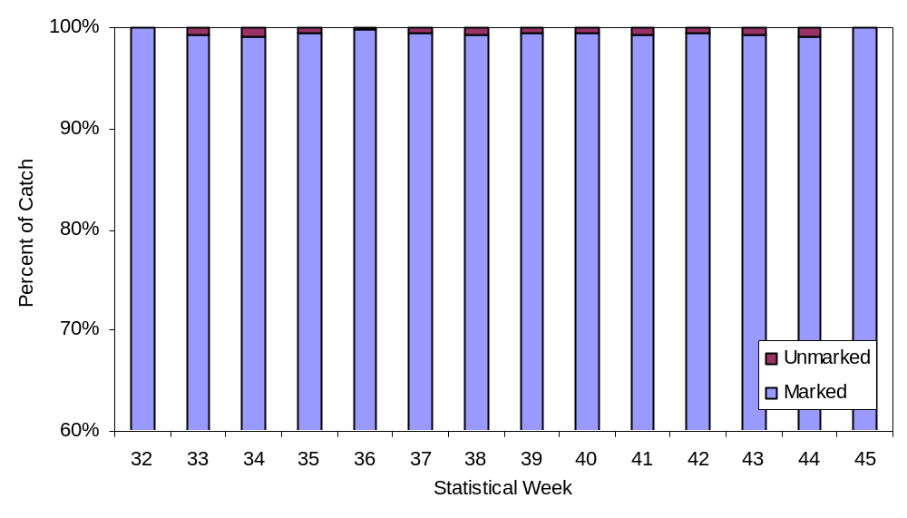

Figure 5. Average weekly catch composition (percent marked and unmarked) of coho harvested in Select Area commercial fisheries, 2002-2006. Note y-scale range from 60% - 100% (necessary to show unmarked component).

In this report we estimate harvest rates for populations originating in tributaries in the Big Creek basin and Youngs Bay. It should be noted that much of the data contained in this report is preliminary in nature. Additionally, several key components needed to accurately calculate harvest rates for these stocks are either incomplete or not available. This report represents our best approximation of harvest rates given the current data available. As new information becomes available and existing information is revised, the results of this report will likely change. A summary of known data gaps and measures used in this analysis to adjust for these gaps, if any, is included in Appendix B at the end of this report.

Catch and Stock Composition
Analyses are based on 2002-2006 catch data for CWTs. We used these years to correspond to spawner population estimates for lower Columbia River tributaries that are available for the same time period. For a complete description of the methods used in estimating AUC population abundance, refer to Suring et al. 2006. For the three Oregon Select Area fisheries sites (Youngs Bay, Blind Slough, and Tongue Point), there were nearly 5,000 CWTs reported in the harvest for 2002-2006.

All CWT codes reported in the harvest were sorted and assigned to one of the three Select Area fisheries sites. There is additional data available that reports CWTs recovered in “mixed” Select Area fisheries, but this data was excluded because it is not site-specific. Once the CWT codes were sorted, release data for each tag group was retrieved from the RMPC website (http://www.rmpc.org).

We calculated the fishery sampling rate for each week that a CWT was recovered (Appendix Table A12). From this we estimated the total number of CWTs recovered per tag code from that fishery in that week. For example, if a fishery recovered 1 CWT from a tag group in one week and we sampled 50% of landings for the presence of a CWT in that week, we estimated that 2 CWTs from that group were actually landed by the fishery.

The tag group release information from RMPC contains numbers of fish marked with CWTs, CWT loss rate, numbers of fish marked with fin clips, numbers of fish with no mark applied at all, and total number released. For each release group, we calculated the percentage of the release that contained a CWT, the percentage of the release that had no mark at all, and the percentage of CWTs that would have been lost due to tag loss at marking.

Using the estimates of the total number of CWTs recovered in a given fishery in a given week, we used the percentage of fish from each group that was marked with a CWT, minus the CWT loss-rate, to calculate how many fish from each release were landed in that fishery in that week. For instance, if we estimated that 2 CWTs were recovered from a release with a CWT mark rate of 20%, then 2 ÷ 0.2 or 10 fish, from that release group, were likely landed in the fishery. If there was a 1% loss rate associated with that group of CWTs, then the mark rate would be reduced from 20% to 19.8% (20%*(1-0.01)) and the number would have been 2 ÷ 0.198, or 10.1 fish. We calculated the number of “marked” fish included in each estimate of CWTs recovered in a fishery separately from the total number of fish represented by subtracting unmarked hatchery fish represented by the CWTs, as described in the following paragraph.

We estimated unmarked hatchery fish represented by the CWTs as follows: first, we multiplied the percentage of each tag group that was released with no marks at all by the estimated total number of fish represented by each tag code. We then summed all the “unmarked hatchery fish” estimates by site and harvest year. Based on the previous example, if for instance, we used an estimate of 2 expanded CWT recoveries, and a 20% CWT rate to estimate that 10 fish from the release group were likely landed in the fishery, and that release group contained 5% fish that had no mark whatsoever, then the fishery likely also landed 10 × 0.05, or 0.5 unmarked fish from that group.

When interpreting the information, we considered marked and unmarked fish separately. For marked fish, we can be 100% certain that they were hatchery-reared fish. Therefore, once we estimated the expanded CWT recoveries and the number of marked fish represented by the marks, we could apply the percentage of marked fish made up of each stock or release group to the total number of marked fish in the catch. Classifying marked fish in this fashion may not accurately ascribe each fish to the correct hatchery, but there is nearly zero chance for a fish classified as a marked hatchery fish to actually be an unmarked naturally-produced fish, and it allowed us to attribute 100% of marked harvest to a specific release group or stock (Table 4). We then broke the estimated marked fish composition into “SAFE Hatchery” or “non-SAFE Hatchery”. The SAFE marked fish category represents any fish captured in one of the three sites that was produced as part of the SAFE program (Big Creek Hatchery coho releases were included in this category), regardless of whether it was caught in its original release site or not. Non-SAFE marked fish were any other marked hatchery fish, whether they were other LCR coho, non-ESU upriver stock, or other. The majority of the non-SAFE hatchery fish are fish from other LCR hatchery programs, but there are a few upriver fish mixed in as well.

Because we don’t know the composition of the unmarked fish, we had to make some assumptions about them. We applied the percentage of non-SAFE marked fish in the marked catch to the unmarked catch, so that if 5% of the marked fish harvest in Youngs Bay in 2006 were from non-SAFE source releases, we assumed that 5% of the unmarked fish harvested in Youngs Bay that year were also from somewhere outside of the SAFE tributary areas (this would include unmarked non-local hatchery fish as well as unmarked naturally-produced fish). Next, we removed the total number of unmarked fish that were assumed to be unmarked fish of hatchery origin from SAFE area releases (identified as unmarked components of releases represented by CWTs recovered in these fisheries). Because we do not know the total composition of unmarked fish, we could not use a percentage to allocate these fish. Instead, we used the estimated number of unmarked hatchery fish and subtracted it from the total unmarked fish catch estimate.

Table 4. Estimated stock composition and origin of marked coho harvested in Oregon Select Area commercial fisheries, 2002-2006.
Marked Hatchery Fish Catch (including jacks)
From Expanded CWT recoveries
Year | Site | Non-SAFE | SAFE | Non-SAFE | SAFE | Total Catch | Non-SAFE | SAFE
2002 | YB | 901 | 39,190 | 2.25% | 97.75% | 50,660 | 1,139 | 49,522
 | TP | 645 | 9,244 | 6.52% | 93.48% | 14,987 | 977 | 14,010
 | BS | 29 | 1,110 | 2.52% | 97.48% | 1,382 | 35 | 1,347
2003 | YB | 1,125 | 79,532 | 1.40% | 98.60% | 88,123 | 1,230 | 86,893
 | TP | 855 | 11,712 | 6.81% | 93.19% | 14,206 | 967 | 13,239
 | BS | 4 | 2,158 | 0.19% | 99.81% | 3,599 | 7 | 3,592
2004 | YB | 413 | 26,934 | 1.51% | 98.49% | 33,583 | 507 | 33,077
 | TP | 63 | 7,601 | 0.82% | 99.18% | 9,877 | 81 | 9,796
 | BS | 63 | 982 | 5.99% | 94.01% | 1,206 | 72 | 1,134
2005 | YB | 510 | 37,139 | 1.36% | 98.64% | 40,880 | 554 | 40,326
 | TP | 341 | 14,478 | 2.30% | 97.70% | 18,108 | 417 | 17,691
 | BS | 56 | 1,114 | 4.81% | 95.19% | 1,713 | 82 | 1,631
2006 | YB | 198 | 12,390 | 1.58% | 98.42% | 20,200 | 318 | 19,881
 | TP | 348 | 7,889 | 4.22% | 95.78% | 10,772 | 455 | 10,317
 | BS | 48 | 1,910 | 2.47% | 97.53% | 2,660 | 66 | 2,594
Sum | YB | 3,147 | 195,185 | 1.59% | 98.41% | 233,446 | 3,712 | 229,734
 | TP | 2,252 | 50,924 | 4.23% | 95.77% | 67,950 | 2,874 | 65,076
 | BS | 200 | 7,274 | 2.68% | 97.32% | 10,560 | 283 | 10,277

Finally, the number of unmarked fish of natural origin that may return from natural production from SAFE tributaries (Table 5) was estimated as: the total unmarked catch minus unmarked catch from outside SAFE (hatchery or other) minus unmarked hatchery catch from SAFE releases. Although the origin of unmarked naturally-produced fish in this analysis is unknown, our estimates assume that all of these fish were destined to return to Select Area tributaries. If fin regeneration information is available, it may be possible to categorize some additional portion of unmarked fish in the catch as unmarked hatchery fish, however, this would only apply to regeneration or mis-clipped fish not already reported in the RMPC system. Following the methods we have used to date, any additional accounting for unmarked hatchery fish would only be applicable to hatchery fish released in SAFE areas, as all other hatchery stocks have already been removed by the preceding analysis steps. Following the 2007 fishing season, scale data will be available from unmarked fish caught in SAFE fisheries. If the scale patterns for hatchery and naturally-produced fish in these areas are sufficiently distinct, it may be possible to apply this information to account for unmarked SAFE-produced hatchery fish in the catch.

Table 5. Estimated stock composition and origin of unmarked coho (including jacks) harvested in Oregon Select Area commercial fisheries, 2002-2006.
Unmarked Fish Catch
From Expanded CWT recoveries
 |  | Total Unmarked Catch |  |  | % of Unmarked
 |  | Non-SAFE Unmarked | SAFE Unmarked | SAFE | Catch =
Year | Site | (hatchery and natural) | Hatchery | Natural | SAFE Natural
2002 | YB | 27 | 1,116 | 56 | 4.68%
 | TP | 37 | 155 | 381 | 66.49%
 | BS | 2 | 11 | 55 | 81.28%
2003 | YB | 46 | 1,661 | 1,605 | 48.46%
 | TP | 95 | 322 | 975 | 70.04%
 | BS | 1 | 44 | 235 | 84.04%
2004 | YB | 16 | 317 | 697 | 67.70%
 | TP | 3 | 74 | 242 | 75.90%
 | BS | 9 | 7 | 133 | 89.43%
2005 | YB | 20 | 223 | 1,209 | 83.29%
 | TP | 15 | 67 | 585 | 87.65%
 | BS | 3 | 8 | 53 | 82.28%
2006 | YB | 12 | 174 | 580 | 75.68%
 | TP | 34 | 154 | 607 | 76.36%
 | BS | 6 | 88 | 131 | 58.28%
Sum | YB | 121 | 3,491 | 4,147 | 53.44%
 | TP | 184 | 772 | 2,790 | 74.48%
 | BS | 21 | 158 | 607 | 77.23%

Harvest Rate Analysis
After we estimated the number of unmarked fish of natural origin that may return from natural production from SAFE tributaries (Table 5), we examined the harvest rate on these “locally-produced” natural coho at each site. For Youngs Bay and Big Creek, we have some estimates of natural and hatchery returns to the tributaries. The Youngs Bay fishery would be expected to impact the Youngs Bay tributaries, while the Tongue Point and Blind Slough fisheries would be expected to affect the Big Creek stock.

Escapement Estimates
Escapement abundance estimates are from the AUC estimates originally calculated by Suring et al. (2006) and revised in December 2007 (personal communication, ODFW Truemper) to split “Astoria Complex” estimates into Big Creek and Youngs Bay components for use in this analysis. The AUC estimates are for total fish abundance, and the number of naturally-produced fish is estimated from fin clips and scale analysis of dead fish sampled in surveys. Because many surveys result in the recovery of few dead fish, sample sizes used to determine the naturally-produced component are often small. Because of concerns with small sample size, we used scale pattern analysis results from weir recoveries to estimate the naturally-produced component of the AUC estimates from the reported estimate for unmarked fish. Methods for incorporating the weir scale pattern data are discussed later in this report.

The estimated number of spawners from the AUC estimates are for fish that spawned in areas below weirs and traps. To estimate total escapement, we added weir counts to the population estimates (Appendix Tables A13 and A14). For the Big Creek population, the weir data comes from Big Creek Hatchery. Big Creek Hatchery operates a fish trap and passes only unmarked coho upstream of the weir to spawn. Counts were available from 2002-2006 that specify total marked and unmarked counts at the weir. Additionally, analyses of scale patterns are available (Tillamook District Office, personal communication) to determine which of the unmarked fish may be naturally-produced fish, versus unmarked hatchery fish. Although these classifications are believed to be reasonably accurate, we present the harvest rate estimates with and without the scale pattern adjustments to provide a range of values in the total estimated numbers of naturally-produced local-stock fish. Without such an adjustment, what would be assumed to be naturally-produced fish would contain some unknown proportion of unmarked hatchery fish. If weir counts for unmarked fish were split into hatchery and naturally-produced fish, the abundance of unmarked fish returning would decline and harvest rate would increase, if harvest wasn’t adjusted accordingly.

For the Youngs Bay population, there is less data available to estimate total escapement. The two locations for which weir counts exist are the North and South Fork Klaskanine facilities. Counts at North Fork have been made consistently, and the counts are subdivided into marked and unmarked fish. The South Fork facility is currently operated by Clatsop County Fisheries. The trap at this site is located off-channel in the outlet of the rearing pond rather than in the South Fork itself. This facility has been recently rebuilt to improve passage. The trap was apparently not always operated during the entire coho run. Although the counts at the site in 2002 (884 fish) and 2003 (1,189 fish) have been relatively large, the number of unmarked fish in these counts is uncertain. Therefore, for 2002 and 2003, we estimated the unmarked component by multiplying the total weir count by the percent of unmarked fish in the North Fork Klaskanine weir in the same years. Counts at South Fork dropped to zero in 2004-2006, in response to the cessation of coho rearing at that site (the trap was likely not operated at all due to no broodstock needs); North Fork counts declined during this period as well. Scale pattern data was available for the 2002-2004 years, but not for 2005 and 2006. For these years, we used the average of the 2003 and 2004 results to estimate the 2005 and 2006 composition (Table 6).

Table 6. Results of scale analysis of unmarked adult coho from weir sites, 2002-2006. Includes all readings.
Klaskanine Scale Analysis (Youngs Bay)
Year | Hatchery | Natural | Sum | Proportion Natural | Comment
2002 | 16 | 4 | 20 | 0.20
2003 | 1 | 25 | 26 | 0.96
2004 | 1 | 5 | 6 | 0.83
2005 | 0 | 0 | 0 | 0.89 | average of 2003-2004
2006 | 0 | 0 | 0 | 0.89 | average of 2003-2004
Big Creek Scale Analysis
Year | Hatchery | Natural | Sum | Proportion Natural
2002 | 16 | 11 | 27 | 0.40
2003 | 187 | 48 | 235 | 0.20
2004 | 10 | 64 | 74 | 0.86
2005 | 66 | 95 | 161 | 0.59
2006 | 59 | 160 | 219 | 0.73

Total counts of fish sampled at weirs in each tributary include adult and jack coho. However, we only used the total number of adults for calculation of harvest rates, since AUC spawner estimates are only for adults. We multiplied the estimated number of unmarked fish counted at the weir by the percentage of adults in the total count to estimate adult unmarked fish at the weirs. This method would not account for differences in jack-to-adult proportions between hatchery and naturally-produced fish. We estimated the total number of unmarked adult coho as the sum of 1) weir counts, 2) spawner estimates, and 3) catch of unmarked locally-produced coho in Select Area fisheries.

Harvest Estimates
Scale pattern data for fisheries recoveries was not available for 2002-2006, so we applied the adjustment from the weir count samples to the catch of unmarked fish for each year and site to estimate the proportion of unmarked catch that is of hatchery origin. It is possible that a higher proportion of unmarked fish in the catch (compared to weir samples) may be hatchery fish due to the propensity of hatchery fish from these locations to mill around the net pens they are reared in as juveniles, creating a higher exposure to the fishery. If this is the case, then the number of naturally-produced fish in the estimated unmarked catch would be lower than indicated here, with the result that estimated harvest rates would also be lower. Further research to document the presence or absence and magnitude of naturally-produced coho in the catch via scale pattern analysis, tagging studies, or other methods are needed to address this uncertainty.

As with our estimates of escapement, we adjusted the commercial catch to reflect only adult coho. In most years, few jacks are harvested in Select Areas (Table 7).

Table 7. Percentage of jacks in total coho catch in Select Areas, 2002-2006.
 | Tongue Point |  |  |  | Blind Slough |  |  |  | Youngs Bay
 | N |  | % |  | N |  | % |  | N |  | %
Year | jacks | samples | adult | jack | jacks | samples | adult | jack | jacks | samples | adult | jack
2002 | 7 | 388 | 0.98 | 0.02 | 7 | 199 | 0.97 | 0.04 | 24 | 1,435 | 0.98 | 0.02
2003 | 0 | 188 | 1.00 | 0.00 | 2 | 341 | 0.99 | 0.01 | 9 | 986 | 0.99 | 0.01
2004 | 48 | 464 | 0.89 | 0.10 | 13 | 294 | 0.96 | 0.04 | 52 | 1,126 | 0.95 | 0.05
2005 | 5 | 535 | 0.99 | 0.01 | 0 | 160 | 1.00 | 0.00 | 16 | 1,284 | 0.99 | 0.01
2006 | 15 | 446 | 0.97 | 0.03 | 22 | 425 | 0.95 | 0.05 | 22 | 794 | 0.97 | 0.03

Harvest Rate Estimates
We estimated harvest rate as the catch in Select Area fisheries divided by the abundance. The harvest rate values for the Youngs Bay and Big Creek populations shown in Tables 8 and 9 include the adjustment from scale pattern analysis, while the values in Tables 10 and 11 do not. The two versions are included because they may be useful for comparing under the two assumptions.

Table 8. Estimated Youngs Bay unmarked coho harvest rates (catch is from Youngs Bay). Includes adjustments based upon scale pattern analysis.
 | Naturally-produced  coho at weirs | Naturally-produced  coho below weirs | Naturally-produced local catch | Naturally-produced  abundance | Naturally-produced  harvest rate
2002 | 18 | 73 | 11 | 101 | 0.109
2003 | 339 | 43 | 1,529 | 1,912 | 0.800
2004 | 8 | 107 | 554 | 669 | 0.828
2005 | 2 | 69 | 1,072 | 1,142 | 0.938
2006 | 5 | 25 | 507 | 537 | 0.944
 |  |  |  | Average | 0.724

Table 9. Estimated Big Creek unmarked coho harvest rates (catch is from Tongue Point and Blind Slough). Includes adjustments based upon scale pattern analysis.
 | Naturally-produced  coho at weirs | Naturally-produced  coho below weirs | Naturally-produced local catch | Naturally-produced  abundance | Naturally-produced  harvest rate
2002 | 19 | 21 | 174 | 214 | 0.814
2003 | 64 | 25 | 247 | 336 | 0.735
2004 | 85 | 0 | 298 | 383 | 0.778
2005 | 106 | 23 | 373 | 503 | 0.743
2006 | 164 | 17 | 519 | 701 | 0.741
 |  |  |  | Average | 0.762

Table 10. Estimated Youngs Bay unmarked coho harvest rates (catch is from Youngs Bay). DOES NOT include adjustments based upon scale pattern analysis.
 | Unmarked  coho at weirs | Unmarked  coho below weirs | Unmarked local catch | Unmarked local  abundance | Unmarked  harvest rate
2002 | 88 | 364 | 193 | 644 | 0.299
2003 | 353 | 45 | 1,878 | 2,275 | 0.825
2004 | 10 | 128 | 791 | 929 | 0.852
2005 | 2 | 77 | 1,408 | 1,487 | 0.947
2006 | 6 | 28 | 664 | 698 | 0.952
 |  |  |  | Average | 0.775

Table 11. Estimated Big Creek unmarked coho harvest rates (catch is from Tongue Point and Blind Slough). DOES NOT include adjustments based upon scale pattern analysis.
 | Naturally-produced  coho at weirs | Naturally-produced  coho below weirs | Naturally-produced local catch | Naturally-produced  abundance | Naturally-produced  harvest rate
2002 | 46 | 52 | 456 | 554 | 0.823
2003 | 313 | 122 | 1,282 | 1,717 | 0.747
2004 | 98 | 0 | 386 | 484 | 0.797
2005 | 180 | 39 | 698 | 917 | 0.761
2006 | 225 | 40 | 794 | 1,059 | 0.750
 |  |  |  | Average | 0.776

Assumptions: These estimates of harvest rates are highly dependent on some key assumptions including:

- All unmarked fish in harvest that cannot be assigned to a “source”, as described in this document, are naturally-produced fish originating in the terminal area where harvested. If some proportion of unmarked fish in the catch originated elsewhere, harvest rate would decrease. Conversely, if some proportion of unmarked fish in the catch that are currently assigned to another source actually originated in the terminal area, harvest rate would be higher than estimated.

- CWTs collected in fisheries represented in this analysis are representative of the origin of stocks harvested in Select Areas. If too few CWTs were recovered to robustly estimate the catch composition by stock, the results of this analysis would be biased. The direction of bias could lead to either over- or under-estimated harvest rates. Included in this assumption is the assumption that the stock distribution in “mixed SAFE” harvest is similar to that reported from the individual SAFE sites.

- Tongue Point fisheries affect Big Creek returns, and are additive with fisheries in Blind Slough. If some proportion of the unmarked fish harvested in Tongue Point and designated as naturally-produced SAFE-area fish in this analysis were actually destined for somewhere other than Big Creek, harvest rates on Big Creek stock would be lower than estimated here.

- Scale pattern analysis of unmarked fish are sufficient to accurately identify fish as either naturally-produced or unmarked hatchery fish. If a higher proportion of these fish were unmarked hatchery fish, naturally-produced harvest rates would increase.

- Counts at weirs in those streams in Youngs Bay that have weirs represent all fish that reach the weir. In fact, some weirs are incomplete barriers, and some are sporadically operated. Counts at these weirs are likely minimum estimates for Youngs Bay. Increased counts of unmarked fish would decrease estimates of harvest rate.

- Sample rates for detection of unmarked fish in landings are large enough to minimize bias in estimates of unmarked fish harvest. Low sample rates may bias estimates, although the direction (high or low) is unknown. Sample rates used to estimate unmarked catch in 2002-2006 were relatively low, although the variance in the estimates is fairly small. Protocols for 2007 and subsequent years have been modified to increase these sampling rates. Sample rates for future years should be similar to those used to detect CWTs in these fisheries (Appendix Table A12).

- Spawner estimates that underestimate the true number of spawners would lead to overestimated harvest rates, and vice versa. Confidence intervals reported for wild spawner estimates in the Astoria Complex and for Youngs Bay and Big Creek individually range from 60% to 157% of the estimate.

- Scale pattern analysis from fish collected at weirs is representative of fish caught in fisheries and those sampled on spawning grounds If more unmarked fish from fisheries are actually hatchery fish, naturally-produced harvest rates would decline, and vice versa. If more unmarked fish from spawning ground surveys are unmarked hatchery fish, harvest rates would increase, and vice versa.

- SAFE and mainstem landings (and unmarked fish) are separate and distinct. Mixing landings during a portion of the season could substantially bias area-specific estimates of unmarked catch. Because a lower proportion of unmarked fish are generally harvested in SAFE fisheries, inclusion of fish from the mainstem would lead to inflated estimates of unmarked catch, and correspondingly increased estimates of harvest rates. Inclusion of fish from the mainstem might also lead to inflated estimates of the proportion of the catch that was “non-local”, which would result in lower estimates of the number of naturally-produced unmarked fish harvested. Because the catch of unmarked fish in Select Areas is typically very low, a relatively small inclusion of fish caught from outside the Select Area fisheries could have a substantial impact on overestimating unmarked catch in Select Areas. We are confident that some catch from mainstem areas is reported as Select Area catch, but have been unable to assess the magnitude or directional bias of this issue.

- Adipose fin regeneration of SAFE releases does not occur, and tag loss rates reported in CWT release reports represent all losses of CWTs. If either of these assumptions were untrue, a proportion of the catch that has been classified as “unmarked” would actually have been comprised of “marked” fish with lost or unreadable marks. Thus, unmarked harvest would be overestimated. Estimates for regeneration of poorly-clipped fins are included in RMPC reports of releases from ODFW and CEDC hatcheries, however comparable data from WDFW and USFWS hatcheries was not available.

Sensitivity Analyses: Because many of these assumptions drastically affect the estimated harvest rates, we used a sensitivity analysis to examine how violations of some of these assumptions could potentially affect our estimates. These analyses are based upon harvest rates estimated with scale pattern adjustments included.

Estimates of Unmarked Fish in Catch

To estimate the effect of the unmarked catch estimate on harvest rates, we performed a sensitivity analysis. We increased and decreased the unmarked catch estimates by five to fifty percent, then calculated the resulting harvest rates. This allowed us to consider how improvements in our estimates of unmarked harvest would affect our estimates of the harvest rate. Opportunities to improve our estimates include more accurate reporting of landings (i.e. reductions in the occurrences of putting unmarked fish from outside Select Areas on Select Area tickets) and, as discussed above, increased sample rate of unmarked fish.

Our estimates of harvest rates were very sensitive to changes in estimates of unmarked catch (Table 12). The Big Creek population was more sensitive to this effect than the Youngs Bay population (Figure 10), possibly because it is assumed to be affected by catch in both Tongue Point and Blind Slough.

Table 12. Effects of errors in unmarked harvest estimates on harvest rate calculations (with scale pattern adjustment).
 | Unmarked Harvest Adjuster (overestimate) |  |  |  |  |  | Unmarked Harvest Adjuster (underestimate)
 | 0.05 | 0.10 | 0.20 | 0.30 | 0.40 | 0.50 | 0.050 | 0.10 | 0.20 | 0.30 | 0.40 | 0.50
Big Creek | Harvest Rates |  |  |  |  |  | Harvest Rates
2002 | 0.806 | 0.799 | 0.784 | 0.770 | 0.757 | 0.744 | 0.821 | 0.829 | 0.845 | 0.862 | 0.879 | 0.897
2003 | 0.726 | 0.716 | 0.698 | 0.681 | 0.665 | 0.649 | 0.745 | 0.755 | 0.776 | 0.799 | 0.822 | 0.848
2004 | 0.770 | 0.762 | 0.745 | 0.730 | 0.715 | 0.701 | 0.787 | 0.796 | 0.815 | 0.834 | 0.854 | 0.875
2005 | 0.733 | 0.724 | 0.707 | 0.690 | 0.674 | 0.658 | 0.753 | 0.762 | 0.783 | 0.805 | 0.828 | 0.852
2006 | 0.731 | 0.722 | 0.704 | 0.687 | 0.671 | 0.656 | 0.750 | 0.760 | 0.781 | 0.803 | 0.826 | 0.851
Average | 0.745 | 0.736 | 0.719 | 0.703 | 0.687 | 0.672 | 0.764 | 0.773 | 0.793 | 0.814 | 0.837 | 0.860
Youngs Bay
2002 | 0.104 | 0.100 | 0.092 | 0.086 | 0.080 | 0.075 | 0.114 | 0.120 | 0.133 | 0.149 | 0.169 | 0.196
2003 | 0.792 | 0.784 | 0.769 | 0.755 | 0.741 | 0.727 | 0.808 | 0.816 | 0.833 | 0.851 | 0.870 | 0.889
2004 | 0.821 | 0.814 | 0.801 | 0.788 | 0.775 | 0.763 | 0.835 | 0.843 | 0.858 | 0.873 | 0.889 | 0.906
2005 | 0.935 | 0.932 | 0.927 | 0.921 | 0.915 | 0.910 | 0.941 | 0.944 | 0.950 | 0.956 | 0.962 | 0.968
2006 | 0.941 | 0.938 | 0.933 | 0.928 | 0.923 | 0.918 | 0.946 | 0.949 | 0.954 | 0.960 | 0.965 | 0.971
Average | 0.836 | 0.829 | 0.816 | 0.804 | 0.792 | 0.780 | 0.849 | 0.856 | 0.870 | 0.884 | 0.899 | 0.914

Effects of Escapement Estimates

The harvest rate estimates are also quite sensitive to estimates of unmarked fish abundance. To examine this effect, we increased and decreased the spawner estimates and weir counts by five to fifty percent, then calculated the resulting harvest rates. Errors in estimates of unmarked fish abundance could occur if there are large numbers of unmarked fish returning to the system that are not counted, if there are large errors in population estimates for unmarked fish, if weirs incompletely block the stream, allowing un-counted fish to escape upstream, or if unmarked hatchery fish are counted as naturally-produced fish.

As with harvest of unmarked fish, our estimates of Big Creek and Youngs Bay harvest rates were very sensitive to changes in our estimates of escapement (Table 13). The Big Creek population was more sensitive to this effect than the Youngs Bay population (Figure10).

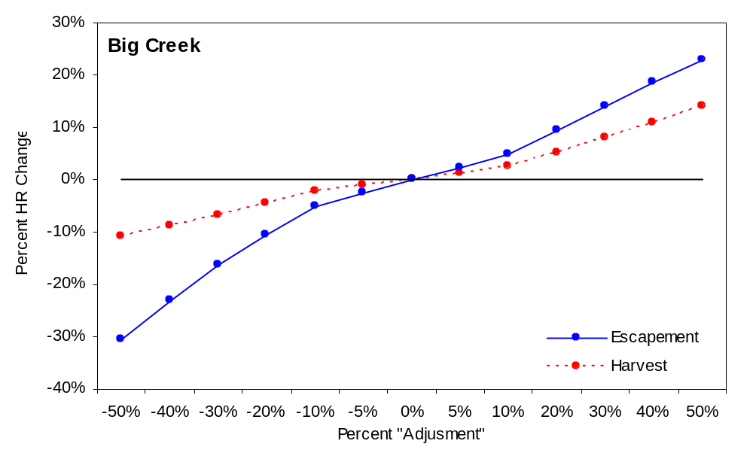
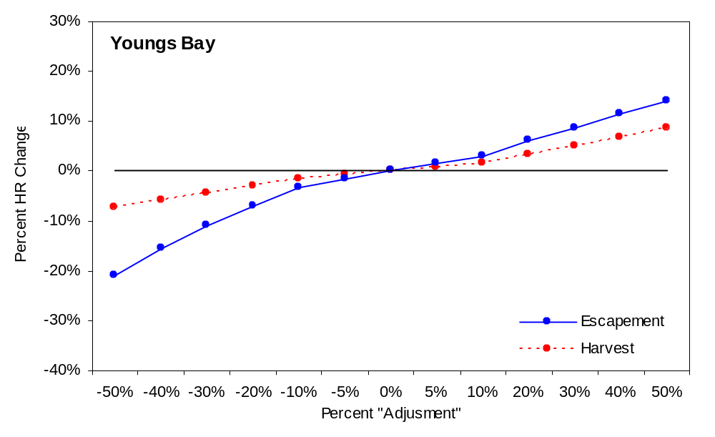

Figure 10. Effects of errors in unmarked harvest estimates and escapement estimates on harvest rate calculations.

Table 13. Effects of errors in unmarked escapement estimates on harvest rate calculations.
 | Unmarked Escapement Adjuster (overestimate) |  |  |  |  |  | Unmarked Escapement Adjuster (underestimate)
 | 0.05 | 0.10 | 0.20 | 0.30 | 0.40 | 0.50 | 0.05 | 0.10 | 0.20 | 0.30 | 0.40 | 0.50
Big Creek | Harvest Rates |  |  |  |  |  | Harvest Rates
2002 | 0.821 | 0.828 | 0.840 | 0.850 | 0.859 | 0.867 | 0.806 | 0.797 | 0.777 | 0.753 | 0.724 | 0.686
2003 | 0.745 | 0.754 | 0.769 | 0.783 | 0.796 | 0.807 | 0.725 | 0.714 | 0.690 | 0.660 | 0.625 | 0.582
2004 | 0.787 | 0.794 | 0.808 | 0.820 | 0.831 | 0.841 | 0.770 | 0.760 | 0.738 | 0.711 | 0.678 | 0.637
2005 | 0.752 | 0.761 | 0.776 | 0.790 | 0.802 | 0.813 | 0.733 | 0.722 | 0.698 | 0.669 | 0.634 | 0.591
2006 | 0.750 | 0.759 | 0.774 | 0.788 | 0.800 | 0.811 | 0.731 | 0.720 | 0.696 | 0.667 | 0.632 | 0.588
Average | 0.763 | 0.772 | 0.787 | 0.800 | 0.811 | 0.822 | 0.745 | 0.734 | 0.711 | 0.683 | 0.648 | 0.606
Youngs Bay | Harvest Rates |  |  |  |  |  | Harvest Rates
2002 | 0.114 | 0.119 | 0.128 | 0.137 | 0.146 | 0.155 | 0.104 | 0.099 | 0.089 | 0.079 | 0.068 | 0.058
2003 | 0.808 | 0.815 | 0.828 | 0.839 | 0.848 | 0.857 | 0.792 | 0.783 | 0.762 | 0.737 | 0.706 | 0.667
2004 | 0.835 | 0.841 | 0.853 | 0.862 | 0.871 | 0.878 | 0.821 | 0.813 | 0.794 | 0.771 | 0.743 | 0.707
2005 | 0.941 | 0.943 | 0.948 | 0.952 | 0.955 | 0.958 | 0.935 | 0.932 | 0.924 | 0.914 | 0.901 | 0.883
2006 | 0.946 | 0.949 | 0.953 | 0.956 | 0.959 | 0.962 | 0.941 | 0.938 | 0.931 | 0.922 | 0.910 | 0.893
Average | 0.848 | 0.854 | 0.865 | 0.874 | 0.882 | 0.889 | 0.835 | 0.828 | 0.810 | 0.789 | 0.762 | 0.727

Feasibility of Escapement Estimates
We estimated spawner-to-spawner ratios for natural-origin fish to examine whether our estimates of spawner abundance for successive generations were biologically feasible. Spawner estimates were not available prior to 2002, and this report utilizes data through 2006, so only two generations (2002/2005 and 2003/2006) were available for this analysis.

Estimates of natural-origin spawners, and corresponding estimates of spawner-to-spawner ratios, vary by population and brood year (Table 14). When the number of natural-origin spawners is estimated using scale pattern analyses to remove unmarked hatchery fish from the calculations, estimated spawner-to-spawner ratios are 0.7 to 3.8 times those that assume all unmarked fish are of natural origin. Ratios calculated by both methods fall within the range observed for coho in the Sandy and Clackamas rivers.

Table 14. Estimated spawner-to-spawner ratios for Youngs Bay and Big Creek coho populations, 2002-2003 brood years. Values include adjustments for scale pattern analysis. Values in parentheses are the corresponding values if the scale pattern adjustment is NOT used.
Youngs Bay population
Brood Yr | Natural-origin Parents | Natural-origin Return (BY+3) |  | Spawner/Spawner
2002 | 90 (452) | 1,142 (1,487) |  | 12.7 (3.3)
2003 | 382 (398) | 537 (698) |  | 1.4 (1.8)
Big Creek population
Brood Yr | Natural-origin Parents | Natural-origin Return (BY+3) |  | Spawner/Spawner
2002 | 40 (98) | 503 (917) |  | 12.6 (9.4)
2003 | 89 (435) | 701 (1,059) |  | 7.9 (2.4)

Estimates of spawner-to-spawner ratios for coho from the 1950s to the present range from 0.19 - 6.46 for the Sandy River population and 0.20 - 14.96 for the Clackamas River population. For both systems, the average ratio is near 2.0 (1.63 Sandy, 1.96 Clackamas). For the Sandy River, the ratio has been above 2 in 20% of the 25 years for which data is available (Table 15). For the Clackamas River, the ratio has been above 2 for 28% of the 47 years available, and above 8 for 4% (2 years). Given these values, the spawner-to-spawner ratios we estimated seem biologically reasonable, although two of the four are quite high.

Table 15. Relative frequency of spawner-to-spawner ratios for the Sandy and Clackamas rivers, 1957-2003.
 | N of years
Spawner to spawner ratio | Sandy | Clackamas
0 | 0 | 0
1 | 11 | 19
2 | 9 | 15
3 | 2 | 6
4 | 0 | 4
5 | 0 | 1
6 | 2 | 0
7 | 1 | 0
8 | 0 | 0
9 | 0 | 0
10 | 0 | 1
11 | 0 | 0
12 | 0 | 0
13 | 0 | 0
14 | 0 | 0
15 | 0 | 1

It should be noted that there are significant gaps in available data necessary to more accurately and precisely estimate abundance of natural-origin fish, in terms of the tributary returns and in terms of the estimated catch in fisheries. Given these uncertainties, values presented in this analysis should be considered approximate and preliminary.

Much more work needs to be done to quantify catch and escapement of naturally-produced fish in Select Area tributaries before robust estimates of harvest rates can be calculated. The range of values for harvest rate shown in our sensitivity analyses may represent the best values for discussion of recovery actions, since they help to demonstrate the effects of various levels of uncertainty. Based on our sensitivity analyses harvest rates for naturally-produced fish in Big Creek range from 58% to 89% and in Youngs Bay range from 5% to 97%.

Some have suggested that harvest rates on naturally-produced fish in these areas may be reduced by altering the run timing of the natural component, the hatchery component, or both. Unfortunately, an assessment of the potential harvest rates under such scenarios is not possible with the data available at this time. Based solely upon timing of unmarked fish in fishery samples and spawning ground surveys, it would appear that unmarked fish are currently present at nearly identical times as marked fish (Figure 7). The coho-directed fisheries in Youngs Bay, Tongue Point, and Blind Slough occur throughout September and October but the majority of the harvest occurs during a 2-3 week timeframe concurrent with peak abundance of hatchery returns during early-mid September. Catch of unmarked fish appears to peak at the same time, although the relative proportion of unmarked fish in the catch stays relatively constant over the period of the fishery (Figure 9). It may be possible to alter the run timing of the returns, however, in order to reduce the harvest rate of unmarked fish in these areas. Such shifts would likely need to be fairly large (3-4 weeks). It should also be noted that peak catches of coho in Youngs Bay in recent years (Figure 7) already occur up to five weeks earlier than when the fishery began in the 1960s (Figure 3), indicating that substantial shifts in the timing of hatchery returns and the fisheries targeting them, relative to the historic timing of naturally-produced coho, have already occurred.

Additional information on the timing of naturally-produced coho in areas where they may be impacted by fisheries is needed to help assess the potential effects of further shifts in run timing. Because there is a high level of uncertainty regarding the timing and harvest of naturally-produced coho in these fisheries, it seems prudent to conduct some basic research to better evaluate the effects of the current fishery and hatchery programs, and to verify the timing of naturally-produced coho, prior to pursuing extensive modifications that may or may not achieve the desired results. This could include tagging studies to identify run timing characteristics of naturally-produced fish, scale pattern analysis to identify hatchery and naturally-produced unmarked fish in the catch, or other methods.

Our analyses of harvest rates for naturally-produced coho in Select Area tributaries reflect a number of uncertainties, as described throughout the report. The following recommendations may help address some of them.

Fishery improvements
- Increase sampling rates for determining unmarked catch in Select Areas (underway).
- Determine the significance of unmarked catch from mainstem fisheries counted under Select Area landing tickets.
- Describe timing patterns of naturally-produced fish in Select Areas where fishery impacts would be expected to occur independent of recoveries from existing fisheries (tagging studies, seasonal test fishing, etc.), including migration through the fishery and fish usage of potential sanctuary areas, such as Battle Creek Slough, the mouth of the Lewis and Clark River, etc.
- Collect and examine scales from unmarked fish landed in Select Area fisheries to determine origin of these fish (underway). Build a suitable reference library for interpretation of hatchery and wild scale patterns. Examine rearing patterns of juvenile hatchery and naturally-produced coho to help in interpreting scale patterns.
- Examine potential additional methods for identifying origin of unmarked fish (application of thermal or scale marks to hatchery fish, increased CWT marking of hatchery fish, etc.).
- Consider development of a genetic baseline that could be used for identification of naturally-produced and hatchery coho in these areas.

Escapement improvements
- Operate all weirs and fish traps throughout the entire coho run period. Consider additional trapping opportunities to estimate escapement. Install or modify existing weirs as necessary to control and enumerate passage into tributaries.
- Collect scales (and DNA samples) from unmarked fish captured at weirs and traps and in spawning surveys. Build a suitable reference library for interpretation of hatchery and wild scale patterns. Examine rearing patterns of juvenile hatchery and naturally-produced coho to help in interpreting scale patterns.
- Refine spawner abundance estimates to include scale pattern data (or other methods) for identification of naturally-produced fish.
- Consider methods to estimate natural production from Select Area tributaries (juvenile trapping, etc.).
- Examine potential additional methods for identifying origin of unmarked fish (application of thermal or scale marks to hatchery fish, increased CWT marking of hatchery fish, etc.). This would be particularly useful if identification could be made in real-time, allowing the passage of ONLY naturally-produced fish above barriers.
- Consider development of a genetic baseline that could be used for identification of naturally-produced and hatchery coho in these areas.

References

North, J., M. Miller, J. Sewall, T. Jones, A. Dietrichs, T. Miethe. 2006. Select Area Fishery Evaluation Project. Final Project Completion Report October 1993-October 2005. Bonneville Power Administration Project 199306000. Bonneville Power Administration, Portland, Oregon.

Suring, E. J., E. T. Brown, and K. M. S. Moore. 2006. Lower Columbia River Coho Status Report 2002-2004: Population abundance, distribution, run timing, and hatchery influence. Report Number OPSW-ODFW-2006-6. Oregon Department of Fish and Wildlife, Salem, Oregon.

Thompson, D. A. and H. L. Blankenship. 1997. Regeneration of adipose fins given complete and incomplete clips. North American Journal of Fisheries Management 17:647-469.

Appendix A: Ancillary Data

Appendix Table A1. Peak index counts of coho in Youngs River and Little Creek (tributary to Big Creek), 1949-2006. Counts are peak estimates in index sites after December 1 of each year.
Year | Youngs R | Little Cr |  | Year | Youngs R | Little Cr
1949 | 7 | -- |  | 1980 | 0 | 6
1950 | 32 | 32 |  | 1981 | 4 | 0
1951 | 53 | 56 |  | 1982 | 1 | 3
1952 | 24 | 61 |  | 1983 | 2 | 1
1953 | 37 | 22 |  | 1984 | 0 | 0
1954 | 10 | 28 |  | 1985 | 0 | 3
1955 | 25 | 11 |  | 1986 | 6 | 13
1956 | 72 | 30 |  | 1987 | 2 | 1
1957 | 33 | 23 |  | 1988 | 2 | 0
1958 | 44 | 12 |  | 1989 | 0 | 0
1959 | 33 | 15 |  | 1990 | 0 | 0
1960 | 26 | 18 |  | 1991 | 0 | 0
1961 | 46 | 18 |  | 1992 | 0 | 1
1962 | 47 | 23 |  | 1993 | 0 | 1
1963 | 16 | 15 |  | 1994 | 0 | 2
1964 | 48 | 46 |  | 1995 | 1 | 0
1965 | 10 | 19 |  | 1996 | 0 | 0
1966 | 84 | 106 |  | 1997 | 0 | 0
1967 | 3 | 3 |  | 1998 | 0 | 0
1968 | 19 | 25 |  | 1999 | 0 | 0
1969 | 32 | 43 |  | 2000 | 42 | 0
1970 | 13 | 16 |  | 2001 | 5 | 3
1971 | 19 | 5 |  | 2002 | 52 | 20
1972 | 7 | 9 |  | 2003 | 20 | 10
1973 | 4 | 8 |  | 2004 | 7 | 7
1974 | 12 | 0 |  | 2005 | 17 | --
1975 | 6 | 1 |  | 2006 | 6 | 6
1976 | 9 | 8
1977 | 3 | 1
1978 | 2 | 4
1979 | 3 | 3

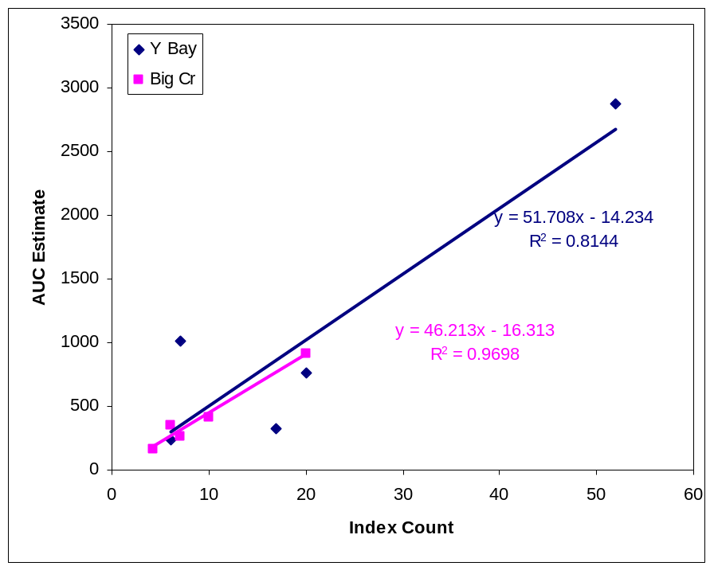

Appendix Figure A1. Linear regression of peak index count versus AUC estimate for 2002-2006 Youngs Bay and Big Creek coho returns.

Appendix Table A2. Estimated total spawner abundance for Youngs Bay and Big Creek back-calculated from 2002-2006 peak count and AUC abundance estimates. Red text indicates interpolated or back-calculated data.
 | Index Peak Counts |  | AUC Estimate
 | Youngs R | Little Cr | Youngs Bay | Big Creek
1949 | 7 |  | 348
1950 | 32 | 32 | 1640 | 1462
1951 | 53 | 56 | 2726 | 2572
1952 | 24 | 61 | 1227 | 2803
1953 | 37 | 22 | 1899 | 1000
1954 | 10 | 28 | 503 | 1278
1955 | 25 | 11 | 1278 | 492
1956 | 72 | 30 | 3709 | 1370
1957 | 33 | 23 | 1692 | 1047
1958 | 44 | 12 | 2261 | 538
1959 | 33 | 15 | 1692 | 677
1960 | 26 | 18 | 1330 | 816
1961 | 46 | 18 | 2364 | 816
1962 | 47 | 23 | 2416 | 1047
1963 | 16 | 15 | 813 | 677
1964 | 48 | 46 | 2468 | 2109
1965 | 10 | 19 | 503 | 862
1966 | 84 | 106 | 4329 | 4882
1967 | 3 | 3 | 141 | 122
1968 | 19 | 25 | 968 | 1139
1969 | 32 | 43 | 1640 | 1971
1970 | 13 | 16 | 658 | 723
1971 | 19 | 5 | 968 | 215
1972 | 7 | 9 | 348 | 400
1973 | 4 | 8 | 193 | 353
1974 | 12 | 0 | 606 | 0
1975 | 6 | 1 | 296 | 30
1976 | 9 | 8 | 451 | 353
1977 | 3 | 1 | 141 | 30
1978 | 2 | 4 | 89 | 169
1979 | 3 | 3 | 141 | 122
1980 | 0 | 6 | 0 | 261
1981 | 4 | 0 | 193 | 0
1982 | 1 | 3 | 37 | 122
1983 | 2 | 1 | 89 | 30
1984 | 0 | 0 | 0 | 0
1985 | 0 | 3 | 0 | 122
1986 | 6 | 13 | 296 | 584
1987 | 2 | 1 | 89 | 30
1988 | 2 | 0 | 89 | 0
1989 | 0 | 0 | 0 | 0
1990 | 0 | 0 | 0 | 0
1991 | 0 | 0 | 0 | 0
1992 | 0 | 1 | 0 | 30
1993 | 0 | 1 | 0 | 30
1994 | 0 | 2 | 0 | 76
1995 | 1 | 0 | 37 | 0
1996 | 0 | 0 | 0 | 0
1997 | 0 | 0 | 0 | 0
1998 | 0 | 0 | 0 | 0
1999 | 0 | 0 | 0 | 0
2000 | 42 | 0 | 2157 | 0
2001 | 5 | 3 | 244 | 122
2002 | 52 | 20 | 2870 | 918
2003 | 20 | 10 | 759 | 413
2004 | 7 | 7 | 1014 | 265
2005 | 17 | 4 | 319 | 163
2006 | 6 | 6 | 241 | 345

Appendix Table A3. Summary of coho releases in Youngs Bay and tributaries, 1962-1993.
Year | ODFW¹ | CEDC²
1962 | 1,120,000
1963 | 1,280,000
1964 | 1,610,000
1965 | 2,660,000
1966 | 1,480,000
1967 | 1,310,000
1968 | 1,200,000
1969 | 1,360,000
1970 | 1,090,000
1971 | 1,990,000
1972 | 1,200,000
1973 | 1,210,000
1974 | 1,220,000
1975 | 1,510,000
1976 | 1,100,000
1977 | 1,130,000 | 50,000
1978 | 1,290,000 | 850,000
1979 | 1,240,000
1980 | 1,410,000 | 200,000
1981 | 2,490,000 | 770,000
1982 | 1,490,000 | 300,000
1983 | 2,180,000 | 320,000
1984 | 2,440,000 | 300,000
1985 | 2,760,000 | 300,000
1986 | 1,930,000 | 400,000
1987 | 1,670,000 | 300,000
1988 | 1,610,000 | 200,000
1989 | 1,680,000 | 430,000
1990 | 1,390,000 | 1,560,000
1991 | 1,260,000 | 2,930,000
1992 | 1,020,000 | 3,080,000
1993 | 850,000 | 4,210,000
1 ODFW primarily Klaskanine Hatchery
2 CEDC primarily Early stock from Bonneville, Sandy, etc.

Appendix Table A4. Summary of open fishing dates and peak catch dates for Youngs Bay Select Area fisheries, 1962-2005.
Year | Open Dates | Open Days | Peak Catch Dates | Comment
1961 | 9/25-28; 10/2-5;  10/9-12; 10/27-31 | 13 |  | Test fishery;  Concurrent with mainstem
1962 | 9/17-19; 9/24-26;  10/1-3; 10/8/11; 10/26-30 | 12 | 10/7-10/10 | Concurrent with mainstem;  Above old 101 bridge to  Battle Cr Slough, L&C sanctuary
1963 | 9/16-10/31 | 45 | 10/7-10/10 | Above old 101 bridge
1964 | 9/14-10/31 | 47 | 9/28-10/5 | Above old 101 bridge
1965 | 9/12-11/15 | 64 | 10/4-10/11 | 9/12-11/15 Above 101 bridge;  9/12-10/31 bet old 101 and new 101
1966 | 9/19-10/31 | 42 | 9/26-10/10 | Above new 101 bridge
1967 | 9/17-10/31 | 44 | 9/25-10/2 | ""
1968 | 9/5-7; 9/13-10/31 | 50 | 9/24-10/1 | ""
1969 | 9/14-10/31 | 47 | 9/24-10/3 | ""
1970 | 9/13-10/31 | 48 | 9/25-10/5 | ""
1971 | 9/12-10/31 | 49 | 9/23-10/1 | ""
1972 | 9/20-11/3 | 44 | 9/23-10/7 | ""
1973 | 9/12-11/2 | 51 | 9/29-10/8 | ""
1974 | 9/17-11/1 | 45 | 9/26-10/5 | ""
1975 | 9/10-10/31; 11/6-7 | 52 | 10/6-10/15 | ""
1976 | 9/7-10/31 | 54 | 10/4-10/12 | ""
1977 | 8/25-10/5; 10/10-27 | 20 | 9/17-9/22 | ""; 11 d in 8/25-10/5 and 9 d in 10/10-27
1978 | 8/24-10/31 | 68 | 9/10-9/18 | ""
1979 | 8/22-10/31 | 70 | 9/3-9/10 & 10/2-10/8 | ""
1980 | 8/24-10/31 | 68 | 9/20-9/30 | Upstream of marker light on RR bridge
1981 | 8/17-11/12 | 87 | 9/11-9/17 | ""
1982 | 8/16-11/6 | 82 | 8/30-9/5 | ""
1983 | 8/22-10/18 | 57 |  | ""
1984 | 8/20-11/2 | 74 |  | ""
1985 | 8/19-11/1 | 74 |  | ""
1986 | 8/10-11/7 | 89 |  | ""
1987 | 8/9-11/6 | 89 |  | ""
1988 | 8/21-10/31 | 71 |  | ""
1989 | 8/20-10/31 | 72 |  | ""
1990 | 8/19-10/31 | 73 | 9/10-9/16 | ""
1991 | 8/18-10/31 | 74 | 9/2-9/8 | ""
1992 | 8/16-10/31 | 76 |  | ""
1993 | 8/22-10/31 | 70 | 9/13-9/19 | ""
1994
1995
1996 | 8/12-9/6; 9/9-10/31 | 62
1997 | 8/11-8/28; 9/3-10/31 | 66
1998 | 8/10-9/4; 9/8-10/31 | 64
1999 | 8/3-9/1; 9/7-10/31 | 59
2000 | 8/1-8/30; 9/5-10/31 | 61
2001 | 8/6-8/28; 9/4-10/31 | 61
2002 | 8/7-8/29; 9/3-10/31 | 62
2003 | 8/6-8/30; 9/2-10/31 | 63
2004 | 8/4-8/29; 8/31-9/3;  9/7-10/31 | 62
2005 | 8/3-8/25; 8/30-9/2;  9/6-10/31 | 63 |  | Upstream boundaries are  confluence of SFK and NFK for  part of season, L&C boundary reduced  from historic.
2006
2007

Appendix Table A5. Summary of releases of hatchery adult and jack coho in lower Columbia River tributaries, 1964-1984.
Date | Hatchery | Released in… | Adults | Jacks |  | Date | Hatchery | Released in… | Adults | Jacks
10/26/1966 | Big Creek | Beaver Cr (Clatsk) | 150 |  |  | 11/7/1964 | Klaskanine | SF Klaskanine | 250
10/22/1968 | Big Creek | Beaver Cr (Clatsk) | 200 |  |  | 11/6/1965 | Klaskanine | SF Klaskanine | 250
11/12/1964 | Big Creek | Beaver Cr (Clatsk) | 100 |  |  | 11/18/1965 | Klaskanine | SF Klaskanine | 150
11/30/1964 | Klaskanine | Beaver Cr (Clatsk) | 180 |  |  | 11/19/1965 | Klaskanine | SF Klaskanine | 200
12/1/1964 | Klaskanine | Beaver Cr (Clatsk) | 20 |  |  | 11/20/1965 | Klaskanine | SF Klaskanine | 150
11/19/1965 | Klaskanine | Beaver Cr (Clatsk) | 150 |  |  | 11/29/1965 | Klaskanine | SF Klaskanine | 148
11/22/1965 | Klaskanine | Beaver Cr (Clatsk) | 150 |  |  | 10/27/1966 | Klaskanine | SF Klaskanine | 159
11/24/1965 | Klaskanine | Beaver Cr (Clatsk) | 150 |  |  | 11/3/1966 | Klaskanine | SF Klaskanine | 266
11/26/1965 | Klaskanine | Beaver Cr (Clatsk) | 175 |  |  | 11/28/1966 | Klaskanine | SF Klaskanine | 230
10/25/1966 | Big Creek | Beaver Cr (Clatsk) | 300 |  |  | 10/5/1967 | Klaskanine | SF Klaskanine | 226 | 80
11/18/1965 | Klaskanine | Gobel Cr | 100 |  |  | 10/25/1970 | Klaskanine | SF Klaskanine | 200
10/28/1966 | Big Creek | Goble Cr | 100 |  |  | 11/26/1971 | Klaskanine | SF Klaskanine | 179 | 29
11/19/1965 | Klaskanine | Green Cr | 100 |  |  | 11/17/1972 | Big Creek | SF Klaskanine | 228
10/28/1966 | Big Creek | Green Cr | 100 |  |  | 11/27/1972 | Klaskanine | SF Klaskanine | 180
11/6/1965 | Klaskanine | Hunt Cr | 100 |  |  | 11/25/1974 | Klaskanine | SF Klaskanine | 202
11/4/1964 | Klaskanine | Lewis & Clark R | 104 |  |  | 11/26/1965 | Klaskanine | Skipanon R | 126
11/5/1964 | Klaskanine | Lewis & Clark R | 202 |  |  | 11/27/1966 | Klaskanine | Skipanon R | 8
11/6/1964 | Klaskanine | Lewis & Clark R | 100 |  |  | 11/13/1964 | Big Creek | Tide Cr | 100
11/8/1965 | Klaskanine | Lewis & Clark R | 150 |  |  | 11/30/1964 | Klaskanine | Tide Cr | 120
11/10/1965 | Klaskanine | Lewis & Clark R | 290 |  |  | 10/24/1966 | Big Creek | Tide Cr | 250
11/15/1965 | Klaskanine | Lewis & Clark R | 60 |  |  | 11/20/1965 | Klaskanine | Walluski R | 150
11/26/1965 | Klaskanine | Lewis & Clark R | 240 |  |  | 11/29/1965 | Klaskanine | Walluski R | 100
10/28/1966 | Klaskanine | Lewis & Clark R | 262 |  |  | 11/8/1966 | Klaskanine | Walluski R | 255
11/2/1966 | Klaskanine | Lewis & Clark R | 275 |  |  | 11/4/1964 | Klaskanine | Youngs R | 104
11/4/1966 | Klaskanine | Lewis & Clark R | 250 |  |  | 11/6/1964 | Klaskanine | Youngs R | 202
10/4/1967 | Klaskanine | Lewis & Clark R | 463 | 153 |  | 11/7/1964 | Klaskanine | Youngs R | 200
10/15/1968 | Big Creek | Lewis & Clark R | 300 |  |  | 11/6/1965 | Klaskanine | Youngs R | 160
10/6/1969 | Klaskanine | Lewis & Clark R | 200 |  |  | 11/8/1965 | Klaskanine | Youngs R | 204
11/12/1969 | Klaskanine | Lewis & Clark R | 116 |  |  | 11/10/1965 | Klaskanine | Youngs R | 170
10/26/1970 | Klaskanine | Lewis & Clark R | 200 |  |  | 11/15/1965 | Klaskanine | Youngs R | 266
11/19/1971 | Klaskanine | Lewis & Clark R | 200 |  |  | 10/28/1966 | Klaskanine | Youngs R | 260
11/26/1971 | Klaskanine | Lewis & Clark R | 102 | 31 |  | 11/2/1966 | Klaskanine | Youngs R | 288
11/15/1972 | Big Creek | Lewis & Clark R | 200 |  |  | 11/3/1966 | Klaskanine | Youngs R | 270
11/30/1972 | Klaskanine | Lewis & Clark R | 82 |  |  | 10/5/1967 | Klaskanine | Youngs R | 450 | 153
11/14/1974 | Klaskanine | Lewis & Clark R | 182 |  |  | 10/14/1968 | Big Creek | Youngs R | 300
11/26/1974 | Klaskanine | Lewis & Clark R | 209 |  |  | 10/15/1968 | Big Creek | Youngs R | 300
11/13/1964 | Big Creek | Merrill Cr | 68 |  |  | 10/6/1969 | Klaskanine | Youngs R | 200
10/26/1966 | Big Creek | Merrill Cr | 150 |  |  | 10/25/1970 | Klaskanine | Youngs R | 200
11/24/1964 | Big Creek | Milton Cr | 100 |  |  | 10/26/1970 | Klaskanine | Youngs R | 200
11/25/1964 | Big Creek | Milton Cr | 350 |  |  | 11/23/1971 | Big Creek | Youngs R | 191 | 74
12/1/1964 | Klaskanine | NF Scappoose Cr | 50 |  |  | 11/29/1971 | Klaskanine | Youngs R | 134 | 102
11/28/1966 | Klaskanine | NF Klaskanine R | 113 |  |  | 11/15/1972 | Big Creek | Youngs R | 200
11/8/1965 | Klaskanine | Rock Cr (Gnat Cr) | 100 |  |  | 11/16/1972 | Big Creek | Youngs R | 200
11/12/1964 | Big Creek | Scappoose Cr | 100 |  |  | 11/20/1974 | Klaskanine | Youngs R | 200
11/24/1964 | Big Creek | Scappoose Cr | 100
11/25/1964 | Big Creek | Scappoose Cr | 300
11/28/1964 | Big Creek | Scappoose Cr | 270
12/1/1964 | Klaskanine | SF Scappoose Cr | 80
10/27/1966 | Big Creek | SF Scappoose Cr | 275

Appendix Table A6. Approximate spawner-to-spawner ratios for Youngs River and Big Creek (Little Creek surveys) coho, BYs 1949-2003. Estimates were derived using the back-calculated 1949-2001 and estimated 2002-2003 abundance.
Youngs River |  |  |  |  | Little Creek
BY | Brood | Return | Ret/Brood |  | BY | Brood | Return | Ret/Brood
1949 | 348 | 1227 | 3.53 |  | 1949 |  | 2803
1950 | 1640 | 1899 | 1.16 |  | 1950 | 1462 | 1000 | 0.68
1951 | 2726 | 503 | 0.18 |  | 1951 | 2572 | 1278 | 0.50
1952 | 1227 | 1278 | 1.04 |  | 1952 | 2803 | 492 | 0.18
1953 | 1899 | 3709 | 1.95 |  | 1953 | 1000 | 1370 | 1.37
1954 | 503 | 1692 | 3.37 |  | 1954 | 1278 | 1047 | 0.82
1955 | 1278 | 2261 | 1.77 |  | 1955 | 492 | 538 | 1.09
1956 | 3709 | 1692 | 0.46 |  | 1956 | 1370 | 677 | 0.49
1957 | 1692 | 1330 | 0.79 |  | 1957 | 1047 | 816 | 0.78
1958 | 2261 | 2364 | 1.05 |  | 1958 | 538 | 816 | 1.52
1959 | 1692 | 2416 | 1.43 |  | 1959 | 677 | 1047 | 1.55
1960 | 1330 | 813 | 0.61 |  | 1960 | 816 | 677 | 0.83
1961 | 2364 | 2468 | 1.04 |  | 1961 | 816 | 2109 | 2.59
1962 | 2416 | 503 | 0.21 |  | 1962 | 1047 | 862 | 0.82
1963 | 813 | 4329 | 5.32 |  | 1963 | 677 | 4882 | 7.21
1964 | 2468 | 141 | 0.06 |  | 1964 | 2109 | 122 | 0.06
1965 | 503 | 968 | 1.93 |  | 1965 | 862 | 1139 | 1.32
1966 | 4329 | 1640 | 0.38 |  | 1966 | 4882 | 1971 | 0.40
1967 | 141 | 658 | 4.67 |  | 1967 | 122 | 723 | 5.91
1968 | 968 | 968 | 1.00 |  | 1968 | 1139 | 215 | 0.19
1969 | 1640 | 348 | 0.21 |  | 1969 | 1971 | 400 | 0.20
1970 | 658 | 193 | 0.29 |  | 1970 | 723 | 353 | 0.49
1971 | 968 | 606 | 0.63 |  | 1971 | 215 | 0 | 0.00
1972 | 348 | 296 | 0.85 |  | 1972 | 400 | 30 | 0.07
1973 | 193 | 451 | 2.34 |  | 1973 | 353 | 353 | 1.00
1974 | 606 | 141 | 0.23 |  | 1974 | 0 | 30
1975 | 296 | 89 | 0.30 |  | 1975 | 30 | 169 | 5.64
1976 | 451 | 141 | 0.31 |  | 1976 | 353 | 122 | 0.35
1977 | 141 | 0 | 0.00 |  | 1977 | 30 | 261 | 8.73
1978 | 89 | 193 | 2.16 |  | 1978 | 169 | 0 | 0.00
1979 | 141 | 37 | 0.27 |  | 1979 | 122 | 122 | 1.00
1980 | 0 | 89 |  |  | 1980 | 261 | 30 | 0.11
1981 | 193 | 0 | 0.00 |  | 1981 | 0 | 0
1982 | 37 | 0 | 0.00 |  | 1982 | 122 | 122 | 1.00
1983 | 89 | 296 | 3.32 |  | 1983 | 30 | 584 | 19.55
1984 | 0 | 89 |  |  | 1984 | 0 | 30
1985 | 0 | 89 |  |  | 1985 | 122 | 0 | 0.00
1986 | 296 | 0 | 0.00 |  | 1986 | 584 | 0 | 0.00
1987 | 89 | 0 | 0.00 |  | 1987 | 30 | 0 | 0.00
1988 | 89 | 0 | 0.00 |  | 1988 | 0 | 0
1989 | 0 | 0 |  |  | 1989 | 0 | 30
1990 | 0 | 0 |  |  | 1990 | 0 | 30
1991 | 0 | 0 |  |  | 1991 | 0 | 76
1992 | 0 | 37 |  |  | 1992 | 30 | 0 | 0.00
1993 | 0 | 0 |  |  | 1993 | 30 | 0 | 0.00
1994 | 0 | 0 |  |  | 1994 | 76 | 0 | 0.00
1995 | 37 | 0 | 0.00 |  | 1995 | 0 | 0
1996 | 0 | 0 |  |  | 1996 | 0 | 0
1997 | 0 | 2157 |  |  | 1997 | 0 | 0
1998 | 0 | 244 |  |  | 1998 | 0 | 122
1999 | 0 | 2870 |  |  | 1999 | 0 | 918
2000 | 2157 | 759 | 0.35 |  | 2000 | 0 | 413
2001 | 244 | 1014 | 4.15 |  | 2001 | 122 | 265 | 2.17
2002 | 2870 | 319 | 0.11 |  | 2002 | 918 | 163 | 0.18
2003 | 759 | 241 | 0.32 |  | 2003 | 413 | 345 | 0.84

Appendix Table A7. Estimated number of unmarked upper Columbia River coho caught in Select Area fisheries, 2002-2006. Estimates derived from CWT expansions as described above.
Year | Youngs Bay | Tongue Point | Blind Slough
2002 | 22 | 26 | 54
2003 | 229 | 90 | 0
2004 | 15 | 0 | 0
2005 | 26 | 27 | 1
2006 | 60 | 14 | 0

Appendix Table A8. Weekly marked and unmarked coho catch in Youngs Bay, 2000-2006.
Unmarked Catch |  |  |  |  |  |  |  | Marked Catch
wk | 2000 | 2001 | 2002 | 2003 | 2004 | 2005 | 2006 | 2000 | 2001 | 2002 | 2003 | 2004 | 2005 | 2006
32 |  | 0 |  |  |  |  |  | 0 | 3 | 1 | 0 | 0 | 0 | 0
33 | 1 |  |  |  |  |  |  | 1 | 14 | 0 | 0 | 3 | 0 | 2
34 | 0 | 8 |  | 0 | 0 |  |  | 1 | 49 | 51 | 2 | 1 | 6 | 3
35 | 0 | 4 | 2 | 51 | 29 |  | 2 | 14 | 92 | 86 | 1,438 | 250 | 57 | 280
36 | 27 | 13 | 85 | 246 | 57 | 96 | 0 | 1,419 | 757 | 18,704 | 17,196 | 3,118 | 2,934 | 1,175
37 | 117 | 816 | 410 | 1,129 | 469 | 781 | 175 | 11,864 | 7,985 | 10,318 | 37,365 | 15,011 | 18,668 | 12,675
38 | 342 | 73 | 539 | 1,270 | 319 | 375 | 289 | 10,874 | 7,320 | 14,111 | 14,367 | 12,861 | 12,210 | 1,942
39 | 106 | 203 | 0 | 123 | 48 | 43 | 42 | 3,087 | 3,968 | 3,108 | 11,723 | 944 | 2,396 | 2,533
40 | 0 | 0 | 29 | 352 | 44 | 54 | 131 | 3,535 | 2,616 | 1,778 | 3,851 | 614 | 1,789 | 467
41 | 0 | 45 | 93 | 117 | 10 | 64 | 113 | 967 | 717 | 2,103 | 1,636 | 236 | 1,548 | 713
42 | 0 | 24 | 28 | 24 | 15 | 9 | 0 | 747 | 553 | 168 | 545 | 263 | 235 | 180
43 | 0 | 12 | 14 |  | 37 | 29 | 11 | 111 | 197 | 232 |  | 238 | 1,038 | 160
44 | 0 |  |  |  |  |  | 4 | 3 | 0 |  |  | 46 |  | 58
45 |  |  |  |  |  |  |  |  |  |  |  |  |  | 12
 | 594 | 1,198 | 1,200 | 3,312 | 1,029 | 1,452 | 767 | 32,622 | 24,271 | 50,660 | 88,123 | 33,584 | 40,880 | 20,200

Appendix Table A9. Weekly marked and unmarked coho catch in Tongue Point, 2000-2006.
Unmarked Catch |  |  |  |  |  |  |  | Marked Catch
wk | 2000 | 2001 | 2002 | 2003 | 2004 | 2005 | 2006 | 2000 | 2001 | 2002 | 2003 | 2004 | 2005 | 2006
32 |  |  |  |  |  |  |  | 0 | 0 | 0 | 0 | 0 | 0 | 0
33 |  |  |  |  |  |  |  | 0 | 0 | 0 | 0 | 0 | 0 | 0
34 |  |  |  |  |  |  |  | 0 | 0 | 0 | 0 | 0 | 0 | 0
35 |  |  |  |  |  |  |  | 0 | 0 | 0 | 0 | 0 | 0 | 0
36 |  | 4 | 174 | 165 | 0 | 79 | 0 | 0 | 101 | 6,331 | 548 | 686 | 1,975 | 0
37 | 39 | 9 | 98 | 1,107 | 102 | 149 | 363 | 1,244 | 660 | 2,687 | 11,928 | 2,991 | 3,546 | 6,897
38 | 154 | 554 | 225 | 71 | 168 | 379 | 247 | 6,091 | 693 | 4,396 | 1,018 | 5,153 | 10,177 | 1,569
39 | 0 |  | 72 | 43 | 42 | 51 | 98 | 1,080 | 0 | 1,271 | 385 | 880 | 899 | 784
40 | 0 |  | 5 | 6 | 4 | 9 | 75 | 1,671 | 0 | 248 | 303 | 108 | 443 | 1,363
41 | 0 |  | 0 | 0 | 0 | 0 | 8 | 450 | 0 | 53 | 12 | 26 | 1,340 | 47
42 | 0 |  |  | 1 | 2 | 2 | 5 | 2 | 0 | 0 | 11 | 34 | 34 | 111
43 |  |  |  |  |  |  |  | 0 | 0 | 0 |  | 0 | 0
44 |  |  |  |  |  |  |  | 0 | 0 |  |  | 0
45
 | 193 | 567 | 573 | 1,392 | 319 | 668 | 795 | 10,538 | 1,454 | 14,987 | 14,206 | 9,877 | 18,416 | 10,772

Appendix Table A10. Weekly marked and unmarked coho catch in Blind Slough, 2000-2006.
Unmarked Catch |  |  |  |  |  |  |  | Marked Catch
wk | 2000 | 2001 | 2002 | 2003 | 2004 | 2005 | 2006 | 2000 | 2001 | 2002 | 2003 | 2004 | 2005 | 2006
32 |  |  |  |  |  |  |  | 0 | 0 | 0 | 0 | 0 | 0 | 0
33 |  |  |  |  |  |  |  | 0 | 0 | 0 | 0 | 0 | 0 | 0
34 |  |  |  |  |  |  |  | 0 | 0 | 0 | 0 | 0 | 0 | 0
35 |  |  |  | 0 | 0 |  |  | 0 | 0 | 6 | 63 | 63 | 0 | 0
36 |  |  | 3 | 0 | 6 | 23 | 0 | 0 | 0 | 35 | 16 | 84 | 210 | 0
37 |  | 6 | 25 | 0 | 11 | 0 | 3 | 438 | 247 | 266 | 409 | 97 | 594 | 89
38 |  | 132 | 14 | 40 | 87 | 20 | 43 | 557 | 883 | 753 | 351 | 687 | 627 | 193
39 | 72 | 36 | 25 | 176 | 32 | 18 | 83 | 677 | 873 | 303 | 1,547 | 222 | 213 | 1,327
40 | 25 | 52 | 1 | 32 | 13 | 0 | 60 | 879 | 564 | 11 | 682 | 52 | 2 | 658
41 | 5 | 12 | 0 | 31 |  | 2 | 20 | 252 | 428 | 8 | 526 | 0 | 68 | 198
42 | 9 | 18 |  | 0 | 0 |  | 14 | 350 | 288 | 0 | 6 | 1 | 0 | 100
43 |  | 9 |  |  |  |  | 0 | 106 | 181 | 0 |  | 0 | 0 | 75
44 |  | 8 |  |  |  |  | 0 | 28 | 27 |  |  | 0 |  | 21
45
 | 111 | 274 | 68 | 280 | 149 | 64 | 224 | 3,287 | 3,490 | 1,382 | 3,599 | 1,206 | 1,713 | 2,660

Appendix Table A11. Weekly sample rates used to estimate catch of unmarked coho in Select Areas, 2002-2006.
 |  | Youngs Bay |  |  |  |  |  |  |  |  |  |  |  |  |  | Tongue Point
Week |  | 2000 |  | 2001 |  | 2002 |  | 2003 |  | 2004 |  |  | 2005 |  | 2006 | 2000 | 2001 | 2002 | 2003 | 2004 | 2005 | 2006
32 |  |  |  |  |  | 1.00
33 |  | 1.00 |  | 0.29 |  |  |  |  |  | 0.33 |  |  |  |  | 0.50
34 |  | 1.00 |  | 0.75 |  | 0.31 |  |  |  |  |  |  | 1.00 |  | 0.67
35 |  | 0.57 |  | 0.55 |  | 0.55 |  | 0.06 |  | 0.14 |  |  | 0.63 |  | 0.43
36 |  | 0.04 |  |  |  | 0.01 |  | 0.00 |  | 0.07 |  |  | 0.05 |  | 0.11 |  |  | 0.03 | 0.02 | 0.01
37 |  | 0.01 |  | 0.02 |  | 0.03 |  | 0.01 |  | 0.01 |  |  | 0.01 |  | 0.01 | 0.10 | 0.12 | 0.02 | 0.01 | 0.05 |  | 0.02
38 |  | 0.01 |  | 0.01 |  |  |  | 0.01 |  | 0.03 |  |  | 0.02 |  | 0.05 | 0.02 | 0.01 | 0.01 |  | 0.04 |  | 0.04
39 |  | 0.03 |  | 0.03 |  |  |  | 0.01 |  | 0.08 |  |  | 0.05 |  | 0.02 | 0.05 |  | 0.08 | 0.16 | 0.09 |  | 0.10
40 |  | 0.03 |  | 0.01 |  |  |  | 0.04 |  | 0.16 |  |  | 0.04 |  | 0.07 | 0.02 |  |  |  | 0.24 |  | 0.05
41 |  | 0.07 |  | 0.22 |  |  |  | 0.01 |  |  |  |  | 0.14 |  | 0.08 | 0.20 |  |  |  |  |  | 1.00
42 |  | 0.02 |  |  |  |  |  |  |  | 0.13 |  |  | 0.44 |  | 0.03
43 |  | 0.46 |  |  |  |  |  |  |  | 0.30 |  |  | 0.10 |  | 0.27
44 |  |  |  |  |  |  |  |  |  | 0.11 |  |  |  |  | 1.03
45
Blind Slough
Week | 2000 |  | 2001 |  | 2002 |  | 2003 |  | 2004 |  | 2005 | 2006
32
33
34
35 |  |  |  |  | 1.00 |  |  |  | 0.06
36 |  |  |  |  |  |  | 0.31 |  | 0.17 |  | 0.04
37 | 0.114 |  |  |  | 0.12 |  | 0.12 |  | 0.09 |  | 0.06 | 0.97
38 | 0.043 |  | 0.02 |  | 0.39 |  | 0.10 |  | 0.21 |  | 0.15 | 0.21
39 | 0.069 |  | 0.17 |  | 0.38 |  | 0.05 |  | 0.31 |  |  | 0.08
40 | 0.04 |  | 0.17 |  | 31.42 |  | 0.13 |  | 0.38 |  |  | 0.08
41 | 0.198 |  | 0.57 |  |  |  | 0.13 |  |  |  |  | 0.30
42 | 0.117 |  | 0.16 |  |  |  |  |  |  |  |  | 0.70
43 | 0.179 |  | 0.45 |  |  |  |  |  |  |  |  | 0.27
44 | 0.75 |  | 0.49
45

Appendix Table A12. Weekly sampling rates for detection of CWT’s in Select Areas, 2002-2006. All sampled coho are electronically sampled for CWT detection.
 | Youngs Bay |  |  |  |  | Tongue Point |  |  |  |  | Blind Slough
Week | 2002 | 2003 | 2004 | 2005 | 2006 | 2002 | 2003 | 2004 | 2005 | 2006 | 2002 | 2003 | 2004 | 2005 | 2006
32 | 1.00
33 |  |  | 0.33 |  | 0.50
34 | 0.41 |  |  | 1.00 | 0.67
35 | 0.48 | 0.39 | 0.14 | 0.63 | 0.43 |  |  |  |  |  | 1.00 |  | 0.06
36 | 0.35 | 0.05 | 0.65 | 0.49 | 0.50 | 0.42 | 0.06 | 0.01 | 0.48 |  |  | 0.31 | 0.17 | 0.23
37 | 0.60 | 0.13 | 0.11 | 0.11 | 0.17 | 0.29 | 0.08 | 0.18 | 0.54 | 0.29 | 0.96 | 0.59 | 0.09 | 0.70 | 0.67
38 | 0.30 | 0.14 | 0.42 | 0.15 | 0.82 | 0.43 | 0.52 | 0.43 | 0.24 | 0.42 | 0.50 | 0.51 | 0.30 | 1.00 | 0.56
39 | 0.40 | 0.26 | 0.42 | 0.58 | 0.37 |  | 0.16 | 0.09 | 0.14 | 0.67 | 0.37 | 0.52 | 0.73 |  | 0.53
40 | 0.23 | 0.55 | 0.16 | 0.10 | 0.35 |  |  | 0.25 | 0.01 | 0.55 |  | 0.84 | 0.86 |  | 0.72
41 |  | 0.04 | 0.29 | 0.69 | 0.08 |  |  |  | 0.73 | 1.00 |  | 1.00 |  | 0.24 | 0.30
42 | 0.04 |  | 0.29 | 0.44 | 0.03 |  |  |  |  |  |  |  |  |  | 0.70
43 |  |  | 0.02 | 0.37 | 0.27 |  |  |  |  |  |  |  |  |  | 1.00
44 |  |  |  |  | 1.00

Appendix Table A13. Weir counts in Youngs Bay tributaries, 2002-2006.
 | Total Weir Counts |  |  | Unmarked Counts
N. Fork Weir | Total | Jack | Adult | Total | Jack | Adult
2002 | 1,107 | 551 | 556 | 73 | 24 | 49
2003 | 303 | 102 | 201 | 80 | 8 | 72
2004 | 168 | 111 | 57 | 29 | 19 | 10
2005 | 32 | 4 | 28 | 2 | 0 | 2
2006 | 34 | 18 | 16 | 12 | 6 | 6
S. Fork Weir | Total | Jack | Adult | Total | Jack | Adult
2002 | 884 | 109 | 775 | 58 | 19 | 39
2003 | 1,189 | 54 | 1,135 | 314 | 33 | 281
2004 | 0 | 0 | 0 | 0 | 0 | 0
2005 | 0 | 0 | 0 | 0 | 0 | 0
2006 | 0 | 0 | 0 | 0 | 0 | 0

Appendix Table A14. Big Creek weir counts, 2002-2006.
 | Total Weir Counts |  |  | Unmarked Counts
Big Cr. Weir | Total | Jack | Adult | Total | Jack | Adult
2002 | 10,303 | 1,938 | 8,365 | 73 | 27 | 46
2003 | 8,918 | 973 | 7,945 | 331 | 18 | 313
2004 | 5,040 | 1,498 | 3,542 | 124 | 26 | 98
2005 | 7,259 | 704 | 6,555 | 201 | 21 | 180
2006 | 7,403 | 1,228 | 6,175 | 252 | 27 | 225

Appendix Table A15. Results of scale analysis of adult coho from weir sites, 2002-2006. With confidence classifications1 of 1 or 2 where possible.
Klaskanine Scale Analysis (Youngs Bay)
Year | H | W | Sum | %Naturally-produced | Comment
2002 | 16 | 4 | 20 | 0.20
2003 | 1 | 24 | 25 | 0.96
2004¹ | 1 | 4 | 5 | 0.80
2005¹ | 0 | 0 | 0 | 0.88 | average of 2003-2004
2006¹ | 0 | 0 | 0 | 0.88 | average of 2003-2004
Big Creek Scale Analysis
Year | H | W | Sum | %Naturally-produced
2002 | 16 | 11 | 27 | 0.40
2003 | 187 | 48 | 235 | 0.20
2004¹ | 9 | 54 | 63 | 0.86
2005¹ | 46 | 79 | 125 | 0.63
2006¹ | 40 | 116 | 156 | 0.74
¹ Classifications for confidence in readings were available for these samples. Classification 1 = high confidence in assignment to correct origin, 2 = fair confidence. Confidence of 3 or no confidence class specified were excluded from these samples.

Appendix B: Known Data Gaps and Adjustments Made

- Spawner index counts for 2005 Big Creek are not available (access denied). Filled in with trend from 2002-2004 and 2006 data points.

- Scale data for Klaskanine weir for 2005 and 2006 not available. Used average of 2003 and 2004 percent naturally-produced.

- Scale data for 2002-2003 weir samples do not have confidence classifications associated with them. Used all data for 2002-2006, regardless of confidence classifications. Appendix Table A15 shows scale pattern results with confidence classifications applied when available

- Scale data not available for fisheries recoveries. Used Youngs Bay and Big Creek weir scale pattern data.

- Scale data for areas below weirs not available. Used weir scale pattern data.

- Production and release histories (including stocks used) for Youngs Bay and Big Creek hatcheries need to be assembled from historic data.

- Weir counts and rack returns from hatcheries need to be assembled from historic data for use in analyzing return timing.

- Migration timing of naturally-produced fish in areas impacted by fisheries (or in any locations other than index-count areas) is unknown.

Another option for estimating the percentage of the unmarked catch that may be hatchery fish is to apply a rate of fin mis-marks and/or regeneration rates to the hatchery component of the catch. We are currently determining whether sufficient data exists to conduct this analysis.

